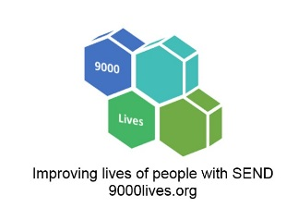
How to write accessible school policies for people with visual impairment or dyslexia.
For 18+ years, all schools have needed an Accessibility Plan. It sets out how school will become more accessible over the years.
The law on this applies to both academies and maintained schools and there are three key areas for schools to consider:
- curriculum
- environment
- information
This article gives quick wins to make your information/documents more accessible to people with visual impairments and dyslexia, including documents on your school website.

Background
Around 4% of the population relies on some sort of assistive technology because of a visual impairment (VI).
This can include:
- Screen reading software
- Refreshable braille displays
- Screen magnifiers
When we write documents, we can make simple tweaks to help our readers with VI.
Follow these tips and you will also end up with clearer information for the 10% of parents estimated to have dyslexia (as most are helpful for both VI and dyslexia).

Seven Helpful Tips

1: Use accessible headings
Word has headings options 1 to 5. They add invisible codes to your document that help screen reader users skip between important bits.
Use them.
Always use Heading 1 for your main title. Then use Heading 2 & 3 for subheadings depending on how important the subheading is.
You'll probably not use Heading 4 or 5 unless you have minor subheadings.
In Word, you’ll find headings in the Styles section:
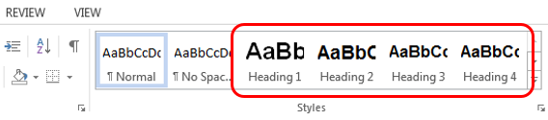
If you find this turns your headings light blue, don’t worry. That’s easily fixed. Right click on your Heading 1, 2, 3 etc and then click modify:
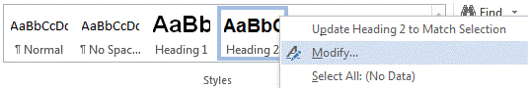
Once you click modify, simply pick your font, colour, size and bold.

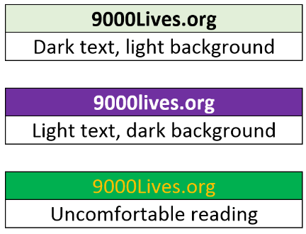
2: Use a good contrast
This means light text on a dark background or vis-a-versa.
Certain bright colour combinations can make text uncomfortable to read.
Don't give your reader a headache!

3: Add Alt Text
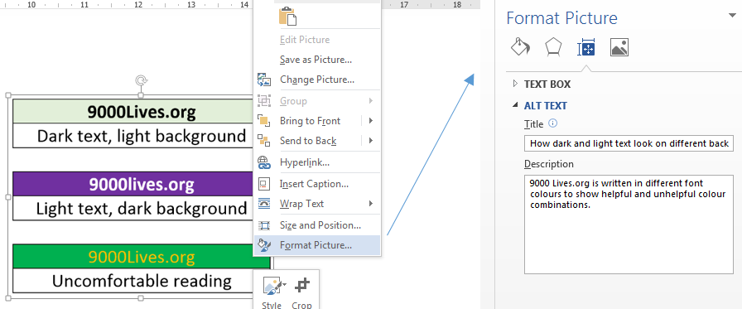
This means adding a description to any picture you use. Think about describing the image to someone over the phone: What does it tell you.
If you use more than 25 words, you are going on too long.
Be short and sweet with your description.
- Right click on image.
- Click Format image.
- Click Layout and Properties.
- Add your text.

4: What's an accessible document format?
MS word or a pdf.

5: Easily convert Word docs to pdfs
Never print your word doc and scan it as a pdf.
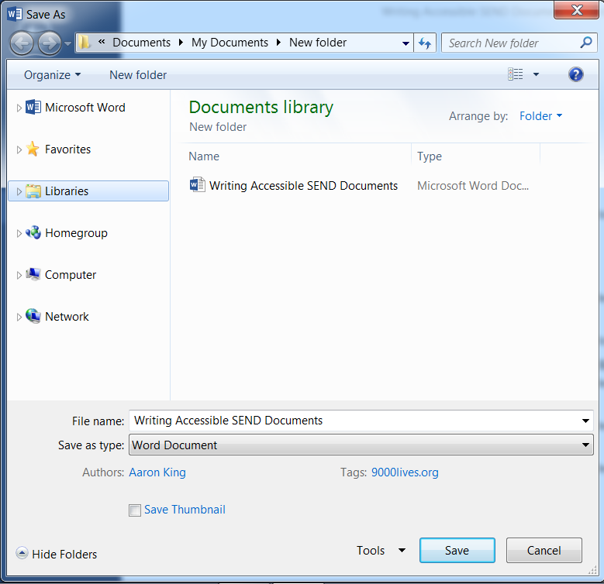
Where pdfs are just scans of printed documents, screen readers can’t read the text. The screen reader say things like “Empty document.” Which means the document can’t be accessed.
If you are converting a word doc to pdf, you can convert the digital file (rather than print it out and scan it as a pdf).
It’s simple to use Save As to turn a word doc into a pdf.
In the File menu, click Save As. Then click Save as type.

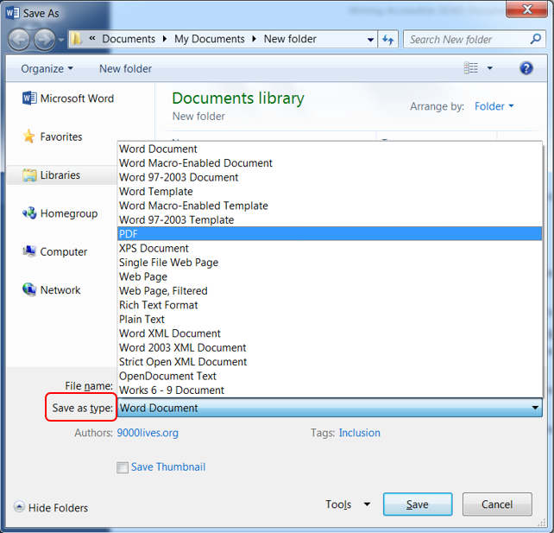
Click (or type) PDF.
Click Save.

6: Accessible Fonts
A serif is a small decoration to finish off letters. Serif fonts include these decorations. The extra detail makes the fonts less readable.
Avoid serif fonts such as Times New Roman. Instead choose a sans-serif font.
Sans-serif means “without serif”, so without the decoration that makes the font harder to read.
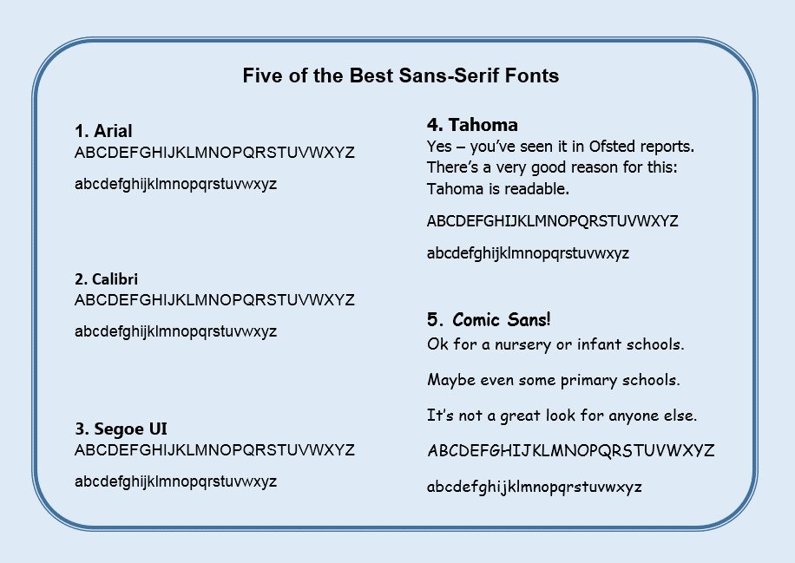
NB: These fonts are also considered dyslexia friendly.

7: Other accessible font tips
- Bold? Yes. This highlights key info and is more legible.
- Size? 14+ for headings. 11 or 12 for your main text.
- Italics? No
- Cursive script? No
- Text in capitals? Never, never, never!

What if I don’t have time to check all my documents?
Then don’t go through them all.
See this as a three - five year project and make improvements when a policy is reviewed.
Some steps are easy (e.g. changing from cursive to a sans-serif font, using size 12, not using scanned pdfs). You may need to take other steps later.
Decide what is realistic at the present time.
Add what you can achieve to both your school's accessibility plan and SEND action plan.

Extra Accessibility Plan Help: Go back to this article on the 9000Lives.org website to find text for your Accessibility Plan. It explains how you are going to make your documents accessible.

Want to try a screen reader: There are several free options. Try NV Access screen reader - click here.

Where can I get more advice or support? Ask questions or get support for your accessibility plan or policies, please get in touch: www.9000Lives.org/contact

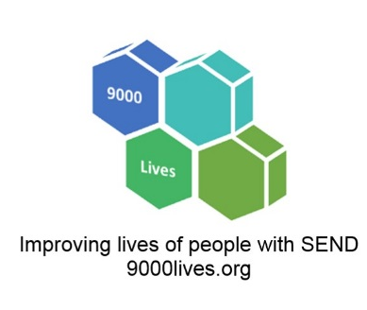
In Summary, use:
- Word or non-scanned Pdf
- Word’s tools to mark headings as headings
- Alt text for images
- Size 12 serif font
- Bold text for headings (size 14+)
- Text that has a good contrast with the background

