15 Youtubers with LGBTQ+ Identities

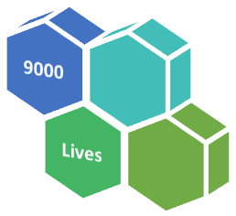
Key
Green boxes = Has a SEND viewpoint.
Blue = No SEND viewpoint.

Where the creator uses swearing, this is flagged.

All these YouTubers are from the UK, unless you see the US flag 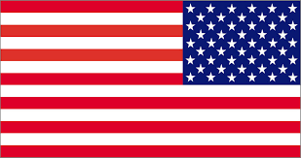.

Niki Albon
A YouTuber from Essex who is also a gay man.

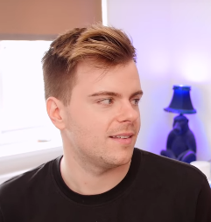
I'm Gay
- youtube.com/watch?v=wiY1vn4poEA
- Talks about being gay & that coming out might not be an explosion, but might just be ripples.

Coming Out to my Twin Brother
- youtube.com/watch?v=Y-krw4G_nj0
- Niki’s accepting twin talks about mum’s sadness when Niki came out (because he hadn’t felt ok to come out sooner).

Doug Armstrong
A YouTuber and musician who is also a gay man.
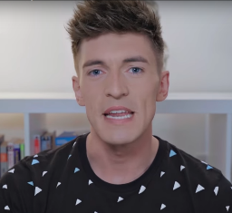

My Coming Out Story
- youtube.com/watch?v=qP1w34vFuIc
- Talks about Doug’s coming out process.

I've been thinking... (coming out)
- youtube.com/watch?v=t88okN9E2Yg
- Doug’s parents were cool when he came out to them. He advocates people coming out and not living in the closet.

Matthew & Ryan
With 600k+ followers on YouTube and 6 million on TikTok, Matthew McKinnon and Ryan Payne are also a gay couple from the UK.
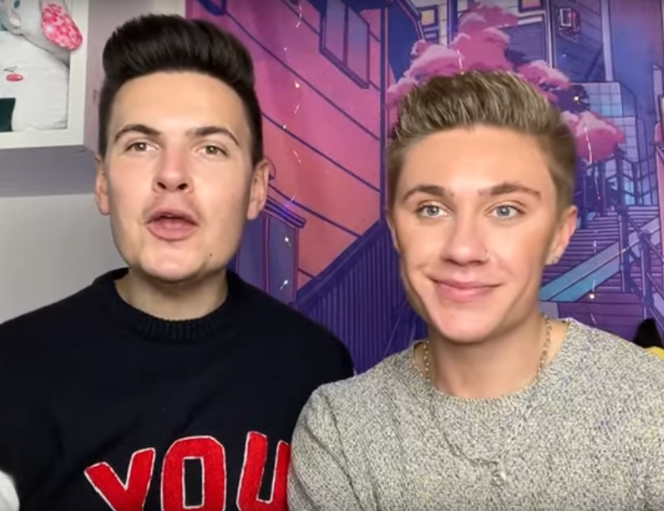

Our Coming Out Stories & LGBTQ+ Advice
- youtube.com/watch?v=iOdyTw1VWhw
- Includes How to come out to Parents (10:20) and Bullying (17:33).

Coming out Gay to your Friends
- youtube.com/watch?v=e8eg1gP7YJU

Ryan O Connell
A successful writer, writing the Netflix series Special, Ryan is gay.
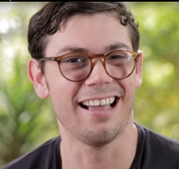

It Took 28 Years For Him To Come Out Of The Disabled Closet…
- youtube.com/watch?v=mv2zGK9IBB0
- It was easy to come out to family, but took longer to accept his disability.

I’m Gay And Disabled And Fine, Thank You
- youtube.com/watch?v=ZZUmUgmc5PE

Some swearing

Phil Lester
A YouTuber from the North West of England. Phil is gay.
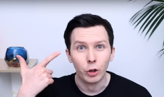

Coming Out To You
- youtube.com/watch?v=UqXFKSWniVU
- Talks about his experience of Coming Out as well as being outed. This worried him. But he feels accepted by his family now.

Megan Evans
Megan is a Youtuber and fertility campaigner. She is also lesbian and in a civil partnership. Megan has a physical disability (she lost fingers and had damage to her arm due to medical negligence at birth).
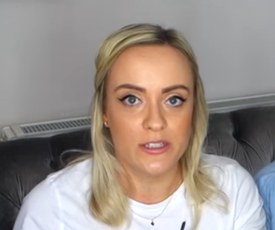
Discussing My Disability
- youtube.com/watch?v=Z4gFVqXQBu4
- Megan chats about her physical disability.

What's It Like Being Gay AND Disabled?!
- youtube.com/watch?v=C_NOEfwCuiQ
- Megan joins Jessica Kellgren-Fozard to talk sexuality and disability.

Jessica Kellgren-Fozard
Jessica is a YouTuber and is lesbian. She became deaf around the age of 15 and some of her videos have Jessica also using sign language (Sign Supported English). Jessica has a visual impairment and an auto immune disorder and a nerve disorder. She also talks about using a mobility aid. She lives in Brighton with her wife, Claudia.
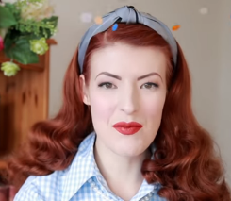

Queer Sign Language
- youtube.com/watch?v=Qq4zd3x_QIA
- Jessica teaches you BSL signs for LGBTQ+

Realising We're Gay
- youtube.com/watch?v=UlnoWnynIfA
- Jessica and her partner talk about their identities.

Mollie Faux-Wilkins (AKA The English Simmer)
Mollie describes herself as a gamer girl. She is bisexual.
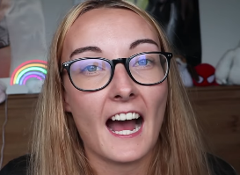

Video Games made me Gay
- youtube.com/watch?v=KTYITvkrLzE
- Talks about how gaming helped her to accept herself. Isn’t too focused on her bisexuality as the video also talks about the details of the games that helped her to realise her sexuality.

Melanie Murphy
A YouTuber who is married with a child and is also bisexual.
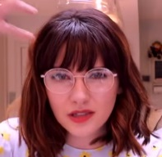

My Boyfriend and My Bisexuality
- youtube.com/watch?v=aqQDkVc0BCo
- Melanie asks her boyfriend about his acceptance of her sexuality.

Life after Coming Out As Bi/Gay
- youtube.com/watch?v=AyGTS-gAqsc
- A joint video with Riyadh K with reflections on having come out.

Some mature content.

Shaaba Lotun
Saaba talks about her relationship with her partner, Jamie Raines, who is a trans man.
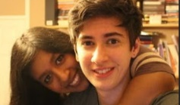

My Coming Out Video | National Coming Out Day
- youtube.com/watch?v=OFM5ZMq_dV8
- Shaaba talks about coming out as bisexual.

Quinn Birkholz
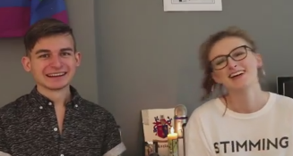
Quinn is an American in the UK. Quinn is a trans woman. This video is prior to that.

Autism, Anxiety, and Being LGBT+
- youtube.com/watch?v=I0OeGzrUNO4
- Two young Youtubers talk anxiety, autism and LGBT+
(Some swearing in some of Quinn’s other videos).

Stephan Kyriacou
Stephan is charity worker who is also a bisexual trans man.
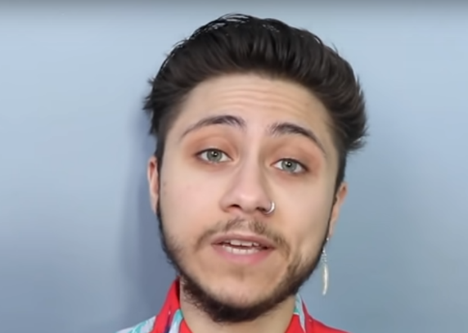

How do you know if you're bisexual? Signs, myths and bisexuality explained
- youtube.com/watch?v=HUoV2MPoDGs
- There’s also an explainer on bi-curious (at 6 min 28s)

Noah Adams AKA Noah Finnce
Noah is a Youtuber and musician who talks about their journey to trans man and also talks about being bisexual. Noah says he potentially has autism and has ADHD.
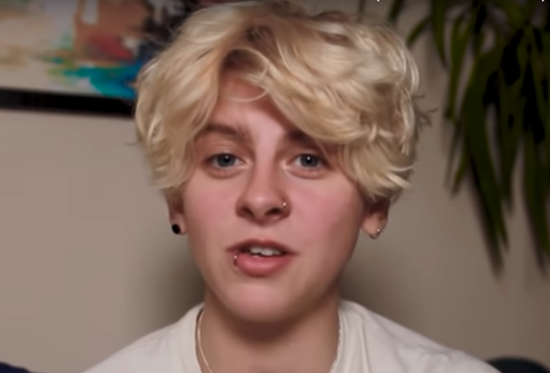

Admitting I’m Bisexual
- www.youtube.com/watch?v=StvX8KfELTo

Alex Bertie
Alex has trans awareness videos as well as content about life after top surgery. Alex is a YouTuber and also a transgender man.
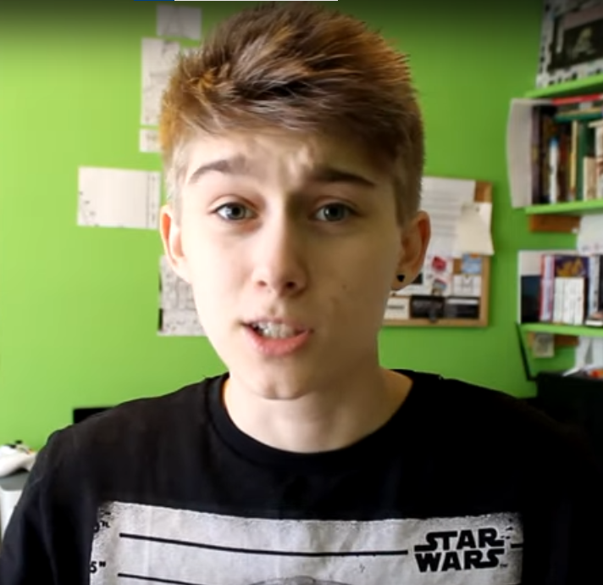

Support Trans People
- youtube.com/watch?v=-g-sAdSTRmY
- Tips on supporting trans people.

Offending Trans People
- youtube.com/watch?v=V8DgzchrcA8
- Gives tips on how to avoid offence to a trans person.

Some swearing 15+

My Genderation
My Genderation celebrates transgender lives and experiences. It tells a range of stories featuring trans people giving their stories first hand, for example:
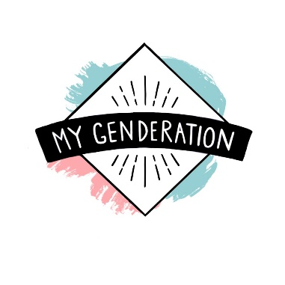

Transgender Boy: Kai, Age 14 - Filmed for 5 years
- https://www.youtube.com/watch?v=DM-91n_qRhE

Does being Trans Change our Sexuality?
- youtube.com/watch?v=88KHCaF8K1U
- Two Youtubers reflect on their sexuality as trans people.

Daniel J Layton
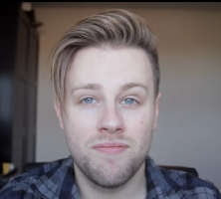
Daniel reflects on what it’s like when people assume you’re gay. He is straight.

How Are You Not Gay Lol
- youtube.com/watch?v=1ODVdZ3V7w0
- Talks about his experiences when people assume he’s gay.

A. Wylde
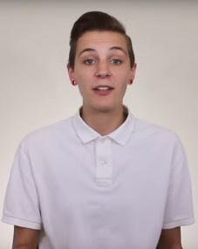
Atlas Wylde is a YouTuber who has made great content on life as a non-binary trans person.

What does Non Binary Mean?
- youtube.com/watch?v=C-uPgD9JNbY
- Explains non-binary in an accessible way.

Supporting someone who is questioning their gender
- youtube.com/watch?v=FQKiOgIdYi4
- Some helpful tips

Non binary swim wear
- youtube.com/watch?v=lytwAmga_i4
- Practical clothing advice!

Tips on using YouTube with ASD people who are also LGBTQ+
1. Watch the videos first: Then you won’t be surprised by any of the content.

2. Chat with the safeguarding lead about your plans: This might mean chatting to parents as well, but not always. For example, being lesbian at 16 isn’t necessarily a safeguarding issue. Local LGBTQ+ charities can often offer advice if a youngster asks that their parent(s) is not told.

3. Filtering Systems: Check that the videos can be accessed in school and aren’t blocked by school IT systems. If so, get in touch with the IT technician to see what solution can be found.

4. Be curious and ask questions: For example, plenty of Youtubers mention bullying. Does being a young YouTuber, who’s talking about their feelings online, mean that bullies have more to target them for? Does this make the bullying ok? Might the bullies might have been bullying for more reasons than just the person’s sexuality (e.g. jealousy).

5. Talk about the comments and trolls: – There are some people who write nasty things on the internet who don’t always mean what they write but put it anyway. They exist. It’s always best to ignore them – Do not feed the trolls.

6. Be happy to say when you don’t know the answer: Have stock answers like “I’m not sure I can answer that right now. Can I think about it and talk about it next time?”

7. Swearing: Some YouTubers swear in their LGBTQ+ videos. Many LGBTQ+ youngsters say they researched LGBTQ+ on YouTube – so they’re watching anyway. What you’re are doing is guiding them to better quality content – rather than leaving them to roam the ‘wild west’ of YouTube themselves, including the most sweary content. It’s ok to acknowledge the swearing in a disapproving way and remind the person of your expectations about appropriate language.

8. Research tells us that good quality relationships & sex education leads to young people waiting longer to have sex and having less of it.

Using English / Non English Subtitles on YouTube
YouTube provide subtitles for all its videos.

You can change how subtitles are displayed via the settings icon at the right side of the screen. This can help improve accessibility for people with visual impairments or dyslexia.

You can also change the language of the subtitles for people whose first language is not English.

Here’s an example:

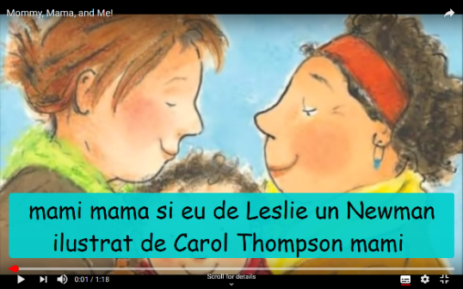
- Font family Casual (similar to Comic Sans)
- Font colour Black
- Font size 400%
- Background opacity 75%
- Window colour Cyan
- Window opacity 100%

Romanian subtitles of Lesliea Newman’s book
Mommy, Mama & Me read by Elizabeth Fisher

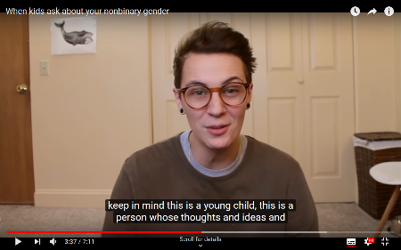
Does your person need more processing time?

A. Wylde / YouTube.com
If the video is going too fast or too slow, you can easily adjust the playback speed. As long as you don’t double the speed, the change to the speech is minimal.
1. Click settings icon at bottom right of video.
2. Can select Playback Speed & slow down speech speed to allow more or less processing time.

And finally…
Subtitles are added by computers at YouTube HQ. Just like humans make mistakes, sometimes the machine makes mistakes and mishears words. It’s not perfect, but it’s pretty good.

Final Tip: Chapters
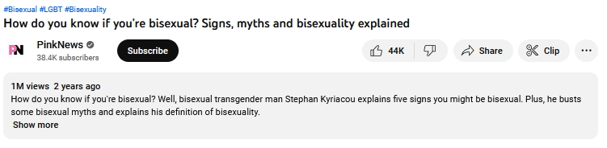
Some creators use chapters for longer videos. This helps you to jump to the most useful bit of the video for you.
You can jump to specific chapters by clicking Show more.
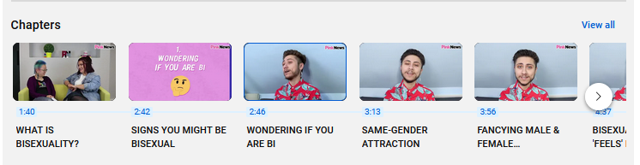
Then scroll down. If chapters are set up, you’ll see something like this. Just click the content you want to jump to.

Credits: All images from Youtube

