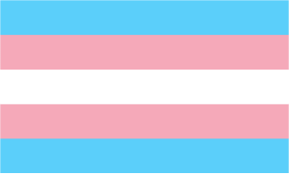
How confident do you feel speaking about transgender?
As an employer, teacher, parents or friend, do you worry about using the wrong words? If so, read on…
Gender is your sense of being a man or woman. It can also be other types of gender that don't fit the man or woman category.

The trans topic is rapidly changing. Here’s ten key terms:

- Transgender: This umbrella term describes someone who is not the same as (or who is not comfortable with) the sex they were assigned on their birth certificate.

- Trans: A shorter version of the word transgender. Many trans people use the terms trans and transgender interchangeably.

- Transman: I was assigned female at birth but now I identify and live as a man.

- Trans woman: I was assigned male at birth but now I identify and live as a woman.

- Non-binary: Non-binary people don't feel male or female. They may:
  - Feel like both
  - Feel like something in between.
  - Not relate to gender at all.

- Cisgender: This describes anyone who is not transgender. It is shortened to “cis “ and is pronounced “sis.” Someone born a man, who identifies as a man and lives as a man would be cis.

- Transitioning: This is the process of making changes from your sex assigned at birth.

Transitioning can include a change of name, change of pronouns used, surgery, hormones and seeking legal recognition of a person’s gender identity.

- Deadnaming: This is when you call a trans person by their previous name (i..e. the name used before transitioning).

Deadnaming is hurtful: Use the person’s present name whenever possible.

- Pronouns (he or she): Often, a trans person’s chosen name indicates their gender preference. So, a trans person called Connor would typically be referred to as “he.”

It is best to respect what the person prefers. This could include terms such as they, their or xe. If you are unsure, politely ask the person what their preferred pronouns are.

- Outing: This term means exposing someone’s trans status.

In short, it is very bad manners because it is best for the trans person to decide about who is told about their identity (with some exceptions).

Is trans more common in people assigned male or assigned female at birth?
Historically, people assigned male at birth made up more of the referrals to gender identity clinics. This has now flipped and, amongst teenagers, people assigned female at birth now make up more of the referrals. You'll not be far off if you work on the basis of referrals being split 3:1 (birth-assigned females vs birth-assigned males).

Are young people's Gender Identity Services closing?
Yes and No. You may have seen news about the closure of the Tavistock Clinic (also known as Gender Identity Development Service (GIDS)). The clinic, which had sites in Leeds and London, is the service for young people who are (in their words) 'presenting with difficulties with their gender identity.'

A review of Gender Identity services for young people by Dr Hilary Cass recommended that services were not offered by the single national clinic.

Instead, from spring 2023, there have been two regions (north and south). The north region clinic will be based in Manchester, whilst the south region clinic will be based in London. The two regions run separately, but meet to help ensure quality and consistent care.

Another key issue that has been highlighted is the steep increase in referrals to GIDS. In 2021/22 there were over 5,000 referrals into the Gender Identity Development Service (GIDS). This compares to about 250 referrals ten years earlier (2011/12).

Is trans gender more common now that before?
It certainly is in the news more often, but no one can be certain as there were more cultural barriers to coming out as trans in the past.
However, we do know that referrals of young people have risen significantly. In 2021/22 there were over 5,000 referrals into the GIDS. This compares to about 250 referrals in 2011/12 (Source: NHS England, May 2023).

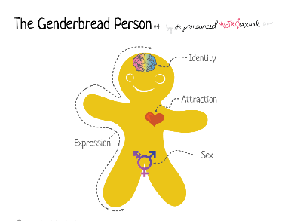
Where do I find more information?
The Genderbread person is a visual way of understanding more about gender identity, sexual orientation and gender expression. Visit genderbread.org.

