How confident do you feel speaking about transgender?
As teachers, teaching assistants, support staff, parents or carers, do you worry about using the wrong words? If so, read on…

Gender is your sense of being a man or woman. It can also be other types of gender that don't fit the man or woman category.

The trans topic is rapidly changing. Here’s ten tips for school staff.

- Transgender: This umbrella term describes someone who is not the same as (or who is not comfortable with) the sex they were assigned on their birth certificate.

- Trans: A shorter version of the word transgender. Many trans people use the terms trans and transgender interchangeably.

- Transman: I was assigned female at birth but now I identify and live as a man.

- Trans woman: I was assigned male at birth but now I identify and live as a woman.

- Non-binary: Non-binary people don't feel male or female. They may:
  - Feel like both
  - Feel like something in between.
  - Not relate to gender at all.

- Cisgender: This describes anyone who is not transgender. It is shortened to “cis “ and is pronounced “sis.” Someone born a man, who identifies as a man and lives as a man would be cis.

- Transitioning: This is the process of making changes from your sex assigned at birth.

Transitioning can include a change of name, change of pronouns used, surgery, hormones and seeking legal recognition of a person’s gender identity.

- Deadnaming: When you call a trans person by their previous name (e.g. a name used before transitioning).

Deadnaming is hurtful. Use the person’s present name at all times possible.

- Pronouns (he or she): Often, a trans person’s chosen name indicates their gender preference. So, a trans person called Connor would typically be referred to as “he.”

It is best to respect what the person prefers. This could include terms such as they, their or xe. If you are unsure, politely ask the person what their preferred pronouns are.

- Outing: This term means exposing someone’s trans status.

In short, it is very bad manners because it is best for the trans person to decide about who is told about their identity (with some exceptions).

Is it more common in people assigned male or female at birth to be transgender?
Historically, those assigned male at birth made up more of the referrals to gender identity clinics.

This is changing. Amongst teenagers, those assigned female at birth are more likely to identify as trans.

One gender identity clinic, The Tavistock Centre, has reported that the rate was about 70% - 30% (birth-assigned males vs birth-assigned females).

Is autism more common in the transgender community?
Research from Cambridge University says yes.

Also, autistic traits are more common in the trans community (i.e. people who show characteristics of autism but do not have a confirmed diagnosis).

Currently, we are not certain why this is.
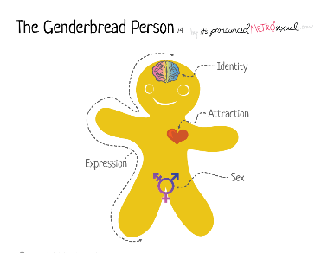
Where do I find more information?
The Genderbread person is a visual way of understanding more about gender identity, sexual orientation and gender expression. Visit genderbread.org.

