Divert CPOMS Notifications away from your Inbox
If you follow this tip, your CPOMS alerts will go to another folder. Most people choose Notes as that isn’t used for much else. If you follow this tip, you must still log onto CPOMS regularly or check you notes folder. If you don’t trust yourself to do this – do not use this tip.

You don’t do this tip by logging into your CPOMS, you do this when logged into your email account and the steps also work for any notifications you get too much of.

Steps
- Log on to your Outlook emails using a computer.
- Click on any notifications@CPOMS.net email from your inbox or deleted items folders.
- Click on the three dots (At the right of the word categories)

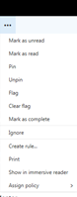
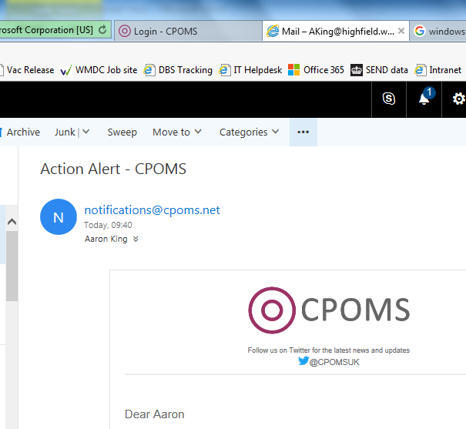

- From the drop down list choose Create Rule...

Some users will need to click on Advanced Options and then Create Rule

The steps are now fairly intuitive so you should be able to set a rule to move all emails from Notifications@CPOMS.net to your Notes folder.

Once you’ve gone through the steps, click 'OK' and it will forward all your CPOMS notifications to your Notes folder automatically. This leaves you inbox with only emails and no CPOMS.

Exceptions: You can also add exceptions. So for example, if you had a student Jack Smith who you are especially worried about, you can add an exception that means his CPOMS will still go into your inbox.

You can use this same system for other problematic emails (e.g. a persistent and vexatious contact who has been told that all communication must be through the head teacher and not you).

