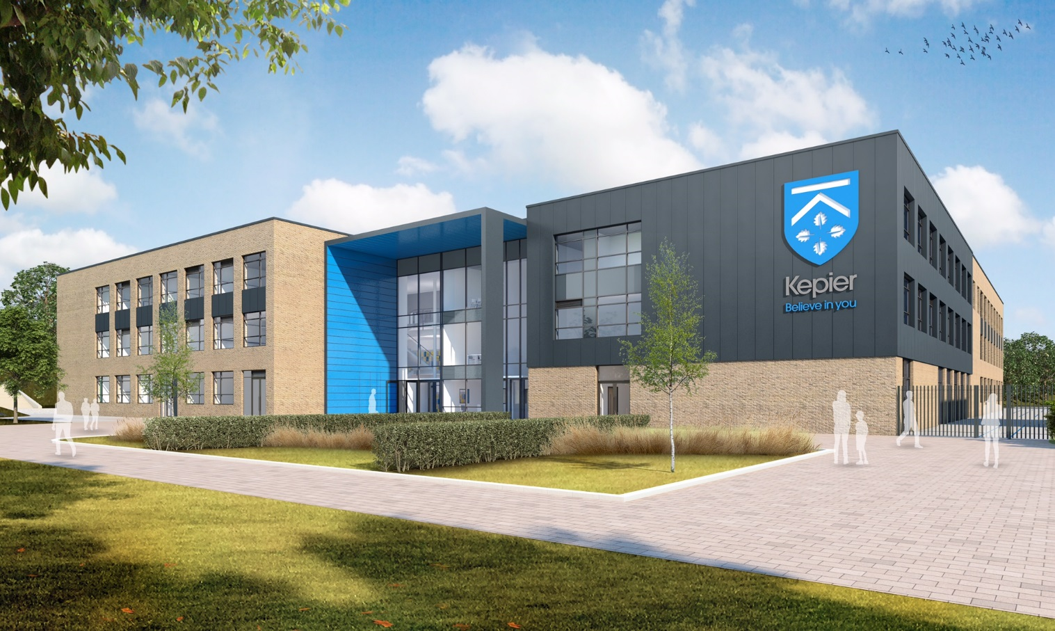

Oak Green Academy

Welcome to SEND

2024 – 25

Our SEND Policy
and
SEND Information Report

Meet the SENDCo
My name is Mrs Mills. My role is Special Educational Needs and Disability Coordinator, or SENDCo for short.
I’ve been at Oak Green for over 5 years and as well as being SENDCo, many students meet me in the science department where I teach two days each week.
This is our combined SEND policy and SEND information report. It tells you how SEND works at our school, and is written for students, parents and staff.

If you have any questions, please get in touch.
T: 01483 555 559
E: k.mills@oakgreen.anyla.sch.uk

Welcome to Oak Green Academy
At Oak Green Academy we focus on students being the best that they can be.
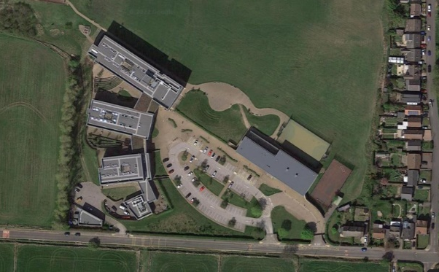
We are a secondary school for students aged 11 to 16. With 7 tutor groups in each year group, we have over 1000 students in total.
Most students walk, cycle or bus from within Anytown, but we also have many students who travel to us from Nextville, Nearton and other local villages.

Oak Green Academy
Kingston Road
Oak Green
Winchester
WF71 3QL
01483 555 555
office@oakgreen.anyla.sch.uk

Contents

3 | What is SEND?  Our ambitions |  | 12 | Our Team: Who’s Who
4 | Types of SEND |  | 13 | Staff Training
5 | Identification of SEND |  | 14 | Specialist Help
6 | How we meet student’s needs |  | 15 | Transition
7 | Assess, Plan, Do, Review |  | 16 | Our Buildings  Equipment for SEND students
8 | Targets |  | 17 | Your Questions Answered
9 | Parental Involvement  Support for Parents |  | 19 | Children who are “Looked After”
11 | The role of Students |  | 20 | Complaints, Exclusions  More Information

This booklet uses the term “parents” to mean anyone who has parental responsibility.

“We can’t believe what he’s achieved over his five years at Oak Green. He’s flourished from a shy nervous boy to a confident happy young man. Who’d have thought that our son would compete in the UK Boccia championship (and win bronze)!”
Parent feedback

Version Information
Last updated: Jan 2024
Updated by: Mrs Mills, SENDCo
Approved by: Governing Body
Next update: Jan 2025

What is SEND?
A student has SEND is they have a learning difficulty or disability that we need to make special provision for.

Some key terms explained:
- Learning Difficulty: When a student finds it harder to learn than most students do.
- Disability (that we need to make special provision for): Something that hinders a student from using our school facilities.
- Special provision: Support that is extra or different to what is typically provided.

What are our ambitions for students who have SEND?
We are ambitious for all our students with SEND. We want them to make excellent progress. This means they will know more, remember more and be able to do more.
We want them to have the knowledge and skills needed for adult life. So, we try to think about the long term as well as the short term. In the long term, we want our students with SEND to:
- have outstanding basic skills (especially in English and maths)
- have superb social skills
- thrive in the workplace
- live a healthy and independent life.

What are the types of SEND?
We follow government guidelines from the SEND Code of Practice. These guidelines split SEND into four categories:
1. Cognition and Learning (C&L), including:
- Learning difficulties;
- Dyslexia & dyscalculia;
- Focus, attention or memory difficulties.

2. Communication and Interaction (C&I), including:
- Autism / ASD;
- Social communication difficulties (other than autism);
- Speech & language difficulties (e.g. receptive language difficulties, selective mutism).

3. Social, Emotional Mental Health (SEMH), including:
- ADHD;
- Anxiety;
- Dysregulated behaviour.

4. Physical / Sensory needs, including:
- Physical needs (e.g. cerebral palsy, dyspraxia);
- Deaf or hearing impairment;
- Blind or visually impairment.

We welcome students with all of the above SEND who applied for a place via our normal admission process. This includes students who have more than one type of SEND.
If a student has complex needs, we consider admissions on a case by case basis (through an Education Health and Care Plan consultation). Please contact our SENDCo to discuss this.

How do we decide if a student has SEND?

We assess students (e.g. reading, writing, maths). Our assessments can also include looking at a student’s social skills or behaviour. You can find more details of this in our assessment policy (On the policies page of our website).
Some parents give us extra information to help us make decisions. For example, this could be an eye clinic report, or an autism diagnosis letter.
Sometimes our assessment might be quick. Sometimes SEND only becomes clear when we assess a student over a longer period. Sometimes, we ask outside experts to assess students (e.g. an Educational Psychologist).
When we assess, we look for:
- Any students who make less progress than their peers;
- Any students who make less progress than they did before;
- Any students who do not close the gap with their peers (despite extra help we have given).

Is it always SEND?
Limited progress does not always mean a student has SEND. When we assess whether a student has SEND we also consider whether other issues may have hindered progress, e.g:
- Low attendance
- Home issues (e.g. bereavement)
- Social issues (e.g. friendships)

Often we address slow progress via adjustments to what we already offer, without needing SEND provision.
A student does not have SEND just because English is not their first language (although they could have SEND as well).

How do we meet students’ needs?
The support needs of our SEND students are very varied. Typically, the higher the need, the more actions we take. For less severe SEND, we might only need two or three small adjustments.
We match the level of support to the student’s level of need. This matching is called our graduated response. The levels of support are often called waves of support and there are three waves of support:
- Wave 1: Support and opportunities for every student.
- Wave 2: Support and opportunities for students who have some concerns.
- Wave 3: SEND support for students to meet their individual needs.

Teachers and support staff all work at all levels of support.
Wave 1
Wave 2
Wave 3

Wave 1
This is quality teaching led by the class teacher. It includes:
- Staff who are ambitious for all their students.
- Well planned lessons that are differentiated (adjusted) to engage all students.
- Grouping students based on ability (sets) in key subjects so that every student gets the best level of challenge in their lessons.
- Regular assessment to so that we know when to move on and what to teach next.
- Behaviour and reward systems that set high standards.
- Homework to reinforce and stretch student learning.

Wave 2
This is for students who need extra support to catch up. For example:
- English or maths booster sessions.
- Extra teacher or support staff time in lessons.
- Social skills or anger management groups.

Wave 3
This means personalised SEND interventions. For example:
- English, maths or science interventions.
- Access to Room 11 (a calm space to spend lunchtimes).
- Social Stories or comic strip conversations.
- Person-centred plans (e.g. Learning Support Page, SEN Support Plan).

Assess, Plan, Do, Review
Assess
Plan
Do
Review

All our SEND support fits into a four-part cycle called Assess, Plan, Do, Review.
- Assess: We establish what the student’s needs are.
- Plan: We set targets and agree how we will support the student to meet them.
- Do: Everyone follows the plans we’ve agreed.
- Review: We look at how successful the plans were. We then agree on next steps.

A cycle takes one school term and there are three cycles per year.

Targets for Students with SEND
We set targets for students with SEND so that staff, parents and students know what we are all working towards. These targets form part of the student’s SEND Support Plan.

We often call these SMART targets:
- Specific: We say exactly what the next small step is for the student.
- Measurable: We say how we know if the student has met their target.
- Achievable: We have big ambitions for the student, but it must be achievable.
- Relevant: We link it to the student’s needs or what they need to overcome.
- Time bound: Targets are for one term.

Examples of Specific Targets
Specific targets say what the student will be able to do. We avoid words that are vague. Instead, we use action words to set targets (read, write, use etc).
- Sam will pass his Entry Level 3 maths.
- Sam will understand that non-verbal communication can convey meaning (e.g. gesture, tone of voice).
- Sam will use calming strategies to self sooth when he is anxious in class.
- Sam will visit the college and choose the course(s) to apply for ahead of Y12.

Parent Involvement
Parents are a crucial to each student’s success:
- Parents’ knowledge helps us to get a shared view of a student's needs.
- Parents tell us what works well at home (these approaches can help us adjust school life).
- Parents attend termly SEND Reviews so their student’s progress is reviewed as a team.
- Parents use ideas from school to help the student at home.
- Parents are just as ambitious for their young person as we are.
When we think a student might have SEND, we discuss this with parents. This is so that we can:
- Listen to the parent’s views;
- Discuss what the next steps might be (this might include setting targets);
- Agree some longer term goals (we refer to these as outcomes).
Excellent teamwork between home and school is vital to the student’s long term success.

Co-Production
The word co-production means parents being a key part of planning SEND support and provision.
Co-production is really important to us. Parents help by coming to SEND reviews and giving their input or by keeping us up to date on any changes in their student’s life.
Importantly, parents help us to improve through our yearly survey. We also value parent feedback on our latest SEND documents (parents gave their views on draft versions of this document).

Parent Support
Family Worker
Mrs Anna Redman is our Family Worker. If you have concerns about a student’s wellbeing, please contact her via the main school number.
She is a friendly face and a listening ear for parents. She is also an expert on the extra support and services that can be accessed locally.

SENDIAS
SENDIAS is an independent team that provides advice and support for parents. Their service is free and help can include:
- Details of local support groups.
- Advice on SEND laws.
- Help to prepare for meetings.
- Help to solve disputes.
Parents get in touch themselves. The service is also free for students aged 16+, who can ask for support directly from SENDIASS all the above issues.

- Tel: 01483 555 955 (Mon – Fri)
- Email: sendias@anyla.gov.uk
- Web: www.anyla.gov.uk/sendias
- Facebook: www.facebook.com/AnyLaSENDIAS

Apart from English, their key leaflets are available in the ten most spoken languages in Southend Schools:
- European: Albanian, Czech, Polish, Portuguese, Romanian
- Asian: Bengali, Chinese (simplified font), Malay, Tamil, Urdu

The Local Offer: https://livewellsouthend.com/kb5/southendonsea/directory/localoffer.page
The Local Offer is a website that is written for parents and families. It helps them know ‘what is out there’ for youngsters with SEND in our local area. It includes:
- Support services
- Health services (e.g. contacts for the NHS speech and language team)
- Special schools
- Leisure activities (e.g. SEN sports clubs)
- Contacts for SEN charities
Our staff, SENDIAS and the Local Offer can all help parents through the SEND maze.

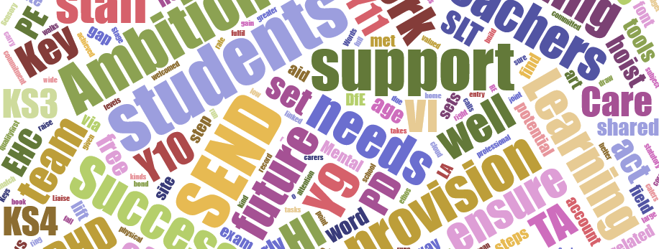
The Role of Students

We expect students to work hard so that they achieve their full potential. They must set the very highest standards for themselves.
It is also important that we listen to their views as this can help us unlock even better progress. Collecting their views includes:
- Asking or observing the student.
- The student completing a survey.
- The student self-assessing their behaviour targets.
- The student coming to their SEND review meeting.
- An annual survey of SEND students.

Can a student with SEND join in clubs, trips and residentials?
Yes – we make adjustments so that students who have SEND can join in all that we have to offer.
Staff may need to talk to the student or their parents to plan adjustments. Or, if a parent or student is worried that their student might need adjustments to be successful, they can contact their form teacher or SENDCo.
It is very rare that we have to make the hard decision for a student to not attend – in the very small number of occasions this is due to safety, wellbeing or both.

Our Team: Who’s Who?

What does our SENDCo do?
- They oversee all of our SEND provision, including setting and monitoring our yearly SEND improvement action plans.
- They advise staff and parents so that students with SEND have both high-quality teaching and ambitious support.
- They identify SEND training needs and make sure that our staff training has a powerful impact on students.
- They oversee and monitor SEND funding and support staff allocation.
- They work with other schools and colleges to help students successfully transfer to us or to move on to the next step of their education.
- They act as the key contact with external SEND support services.

What does our head teacher do?
- They set an inclusive ethos for our academy.
- They ensure we meet our legal duties.
- They regularly review the quality of education that we provide.
- They ensure the SENDCo has enough time to fulfil the role, including admin support.
- They support and challenge the SENDCo.

Every teacher is a teacher of SEND. Teachers will:
- Be accountable for progress of every student they teach, including those who have SEN support.
- Provide excellent differentiated teaching as the key aspect of our SEND support.
- Make lessons accessible for every student.
- Use assessment to plan accessible lessons.
- Follow provision set out in student’s SEND plan(s).
- Follow advice from the SENDCo and any support services.

What do support staff (e.g. teaching assistants) do for SEND students?
Support staff, including teaching assistants, are a key part of our team. They support students in lessons as well as leading SEND programmes outside the classroom. Their SEND work is wide ranging and to help every student achieve their best, all support staff can access any student’s SEND plans.

Our SEND Governor is Mr J Robinson. His role is to:
- Monitor SEND in our school, including our legal duties.
- Monitor long term plans for improving our SEND work.
- Meet with the SENDCo at least three times a year and feedback to other governors about SEND issues.

Staff and governors can be contacted via the main office.

How do we grow our staff SEND expertise?
We use training to keep up to date and enhance our SEND knowledge and skills. To train and develop our team, we use:
- Staff meeting and INSET day training
- Staff supporting each other
- Online courses and evidence, e.g:
          - MindEd: www.minded.org.uk
          - NASEN’s What Works (Whole School SEND)

This training is often led by the SENDCo, as our in house expert. We also use external trainers so that our staff benefit from a broad range of specialist expertise.

What training have our staff had?
We always want to learn more about SEND. Sometimes staff members attend courses to train on a specific topic (e.g. Safeguarding Students with SEND). This knowledge is then shared amongst other teams / departments in the academy.
At other times, the whole staff join together to train on one topic (e.g. autism). If you’d like to know more about any of our training, please contact the SENDCo.

Examples of training for our staff in the past 3 years:
- Learning: e.g. Dyslexia, Toe-by-Toe, Precision teaching.
- Communication & Interaction: e.g. Autism, Comic strip conversations, Social stories.
- Wellbeing and Behaviour: e.g. ACEs, Anxiety, Loss & Trauma, Mental Health.
- Other: e.g. Epilepsy Awareness, Hearing Impairment.

Can we access specialist help?
Yes. Some students have needs that are very specific or complex. Therefore, we work with support services to benefit from specialist advice. You may sometimes hear support services referred to as “external agencies”.

Support Services we work with include:
- Educational Psychology Service (EPS)
- CAMHS
- Autism Service
- Behaviour Outreach Support Service
- Deaf and HI Team / VI Team
- Education & Welfare
- Early Help

For most students, school meets their SEND without needing support service advice. This is because our staff have training and skills to adapt classrooms and lessons to meet their needs.
If we think we ned extra advice from a SEND support service, we discuss this with the student’s parent. The parent makes the final decision.
Support services advise our teachers or the SENDCo. Teachers make sure advice is faithfully followed and the SENDCo monitors this.

Transition
Joining Us from Primary School
When a child has an EHCP, we know of them via the local authority consulting us for a school place. For other SEND children, primary school staff (via the Y6 teacher or SENDCo) alert our SENDCo to any SEND.
Our inclusive transition work includes features that help many SEND children:
- Y6 children have tours and taster lessons.
- Y6 children get a transition booklet.
- We place Y6 children in form groups that take into account existing friendships.
- We visit each primary school where three or more of their children are joining us.

What extra do we provide for Y6 children with SEND?
- SEND children, or their parents, can ask for extra visits if needed.
- We talk to the primary school’s SENDCo to find out about the child’s SEND.
- We aim to attend all summer term SEND reviews for pupils with an EHCP.
- We provide teachers and key staff with the child’s SEND information before they start with us.
Parents whose child will be joining us are always welcome to contact our SENCo to discuss their child’s SEND (by telephone, email or to organise a meeting).

Joining us from another school during Y7 - 11
We contact the student’s current school to get information. One of our SEND team will also contact parents to introduce ourselves. We then plan the transition based on the student’s individuals’ needs.
We ask the current school about any safeguarding issues before the student joins us. This is a normal approach in schools (safeguarding a child is a valid reason to share private information).

Leaving Us
Transfer to Y12 is normally led by the student’s sixth form or college. Parents should look on their website SEND page for more information about this.
We link with the next school or college to pass on SEND information. For those with the greatest needs, we sometimes support extra visits or offer pastoral time so that students can talk about any worries they may have.
For students with an EHCP, we invite SENDCos of Y12 placements to our Y11 Annual Reviews.
If students leave us during Y7 – Y11 (e.g. due to moving house), our school will work with the new school. Transition arrangements will depend on how long we have before the move as well as the nature of the student’s SEND. If parents are thinking of moving, it is helpful if they can get in touch with the SENDCo early so that if plans are needed, these can be sorted as soon as possible.

Buildings and Equipment
We are at the heart of the community and the perfect place for your student's journey to success.
We have four buildings:
- The Glennie Building
- The Peake Block
- The Turner Block
- The Bromby Block (PE, Sports)
All four buildings have step free access and accessible toilets.
All of our buildings, apart from Bromby, are two floors and have lift access to the upper floor. The Bromby Block is all on the ground floor.
The outside areas are all accessed via level paths or ramps. Fences and an intercom on our main entrance help to keep students safe.
We have year group assemblies in the Lecture Theatre in Peake Block. This has a hearing loop to help students with hearing loss. Elsewhere in school, we have several classrooms that have a SoundField system installed:

SEND Equipment
Some students need extra items to help them to be successful. Most of these are not expensive and we buy them from our SEND budget.
From time to time, equipment costs much more than this (e.g. special seating for a student with cerebral palsy). If so, we might ask for outside funding from the local council’s SEND Team.
We do not ask parents to pay for essential SEND items from their own money.

Your Questions Answered

1. Does a student need a diagnosis in order to have SEND?
No. Some students do have a diagnosis (e.g. autism, ADHD), but we can address a student’s SEND even if they don’t have a diagnosis.
We know that families often want diagnosis so that they can be sure what is going on for their student. But, it’s also important that we help the student as soon as we can – so we don’t need to wait for a diagnosis to make adjustments for a student.

2. What is an EHCP?
EHCP is short for Education, Health and Care Plan. This is like a contract between a local council, school and parents.
Most students’ SEND can be met without an EHCP - we use our SEND funding to help with this. A small number of students with more complex SEND have an EHCP (about 2% of all students). Some EHCP students are in special schools and some are in mainstream schools like ours.
More information on EHCPs can be found on the Local Offer website or you can discuss this with our SENDCo.

3. Are emotional difficulties always SEND?
No.
Many students have time when their mood changes (e.g. as parents split up, the death of a family member, exam stress). Such short term distress is rarely SEND. Nevertheless, we have a range of emotional support to offer. We support the student in front of us, regardless of whether it is a SEND.
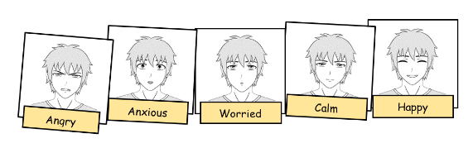
Some experiences do lead to longer term emotional or mental health issues. If so, it might be that the difficulties do become a SEND because we need to make SEND provision that’s extra to our usual pastoral support.
A Y7 emotions scale (a tool to help self-regulate)

4. What support is available for social and emotional needs?
We are proud to be a nurturing and supportive school. We know that students need to feel happy and secure in order to meet their potential.
If a student displays challenging behaviour we try to find the causes and then adapt so things can improve rapidly. We also expect that the student and their parents will work with us to make rapid change.
If needed, we work with parents to identify needs of the family as a whole. This may involve forming a Team around the Family (TAF). A TAF is a series of meetings and action plans that look at the bigger picture for the student. It can also help to remove barriers to learning and agree referrals for extra support for the student, their family, or both.
Some students need specialist help. For these students we may talk to parent about a referral to the Children and Adolescent Mental Health Service (CAMHS). This is an NHS team of mental health experts.
We also have:
- PSHE teaching in Years 7 – 9, covering a range of social and wellbeing themes.
- Clear systems for managing behaviour and rewards.
- Staff who offer pastoral support.
- Liaison with a speech and language therapist who helps us to identify if speech and language difficulties are contributing to a student’s behaviour.
- Plans that allow us to set individual targets for the small number of students who need extra focus and monitoring.
- Visiting speakers on mental health.

5. Can students have adjustments to exams?
Yes – adjustments to exams are called “access arrangements.” Staff and the SEND team identify students who will need access arrangements for their GCSE exams. We follow guidelines from the exam boards and must take into account the students ‘normal way of working.’ The adjustments also apply to internal exams and can include:
Arrangements can include:
- A reader or computer reader
- Extra time
- Scribe and/or the use of a word processor

SEND & Children who are “Looked after”
CLA stands for Children who are “looked after”. Being looked after means that parents are unable to care for a child and the council or court takes on parenting decisions. This can be temporary or permanent. There are a few ways the child’s new care might be provided. Two common ways are foster care or children’s homes.
NSPCC has a good explanation of CLA: learning.nspcc.org.uk/children-and-families-at-risk/looked-after-children.

Mr Tom Powell
Designated Teacher
I lead CLA support in school. The full name for my role is “Designated Teacher for CLA and students who were previously CLA.

Contact me:
- SENDCo@your.sch
- 0123 456 789

For our pupils who are CLA and have SEND, we:
- Monitor progress through a termly Personal Education Plan (PEP).
- As often as we can, schedule PEP meetings at the same time as SEND meetings so that PEPs and SEND plans are joined up.
- Work well with CLA support services (e.g. social workers, Virtual School Headteacher).
- Make sure CLA pupils with SEND can join in extra activities, by making extra arrangements such as:
  - Permission from both a social worker and carer to allow them to go on a residential.
  - Liaising with carers and taxi drivers so that a pupil is collected early and gets to school in time for the trip leaving at 7.45am.
- Give CLA equal access to SEND provision (i.e. no less than they’ would get if not CLA).
- Support staff to understand the effects of loss or separation from birth families.
- Know that SEND can make it even harder for some CLA children to trust adults, and how we might overcome this.
- Have big ambitions for our pupils who are CLA and SEND. National data shows that this group of pupils aren't achieving well enough. We’ll make sure that no CLA & SEND child is failed by us.

Extra Funding (Pupil Premium Plus)
We get extra money for CLA pupils and those who were CLA but aren’t anymore (e.g. pupils who've been adopted after time in foster care). This money is called Pupil Premium Plus. From time to time, you might also hear it being called CLA Pupil Premium.
Being CLA and having SEND does not mean that a pupil is always behind in their learning. For example, a CLA pupil may be very able at maths and English but experience social difficulties that are identified as a SEND.

Other Information

Complaints about SEND
We hope that every student with SEND thrives. But, if a parent does have concerns, they should raise it with the form teacher, teacher involved in the issue or SENDCo.
Our full complaints policy is on our website: OakGreen.co.uk/Policies

Exclusions
We reduce the risk of exclusions by having high standards of behaviour and making adjustments to make school life inclusive. However, you can find out more about exclusions in our Behaviour Policy. This is on the policies page of our website: OakGreen.co.uk/policies

Where to find more SEND Information
Visit OakGreen.co.uk/policies to read our other policies that link to SEND, including our:
Accessibility Policy
- Our policy and three year plan to be even more inclusive.

Anti-bullying Approaches
- How we tackle bullying, including of students with SEND.

Behaviour Policy
- Rewards, rules, sanctions and much more.

If you need paper versions please ask at the main office.

SEND Laws and Guidance
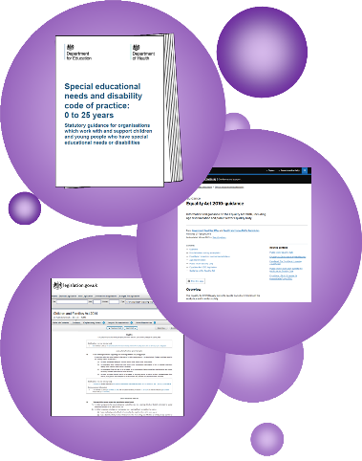
If you want to read more, these are the key SEND rules and laws:
SEND Code of Practice
- This is the Government’s SEND rulebook. You can find it here.
Equality Act
- This 2010 law sets out our duties to make reasonable adjustments for those who have disabilities. It protects people from discrimination. Find out more here.
The Children & Families Act
- This 2014 law outlines our duties for students with SEND. You can find it here (p.21 onwards).

Status of our SEND Policy
This policy is statutory. That means that the law says we must have a SEND policy and a SEND information report. The DfE say that these can be a single document.
We use a single document so that it is easier to find out about our SEND work. This booklet has all the necessary parts of both the SEND Information Report and SEND Policy.

Evaluating our SEND Policy
Our SENDCo & Leadership Team evaluate our policy. They use five ways to judge how well our SEND policy is working:
- Monitoring the progress and results of students.
- Monitoring how well students with SEND meet their targets.
- Regular reviews of interventions with staff.
- Leadership team visits to observe lessons and monitor student’s work.
- Listening to the views of students, parents and staff.

Reviewing this Booklet
Our SENDCo reviews this policy booklet every 12 months. Our governors then approve it or request any changes.

“Keep on climbing,
there’s space for you at the top.”

