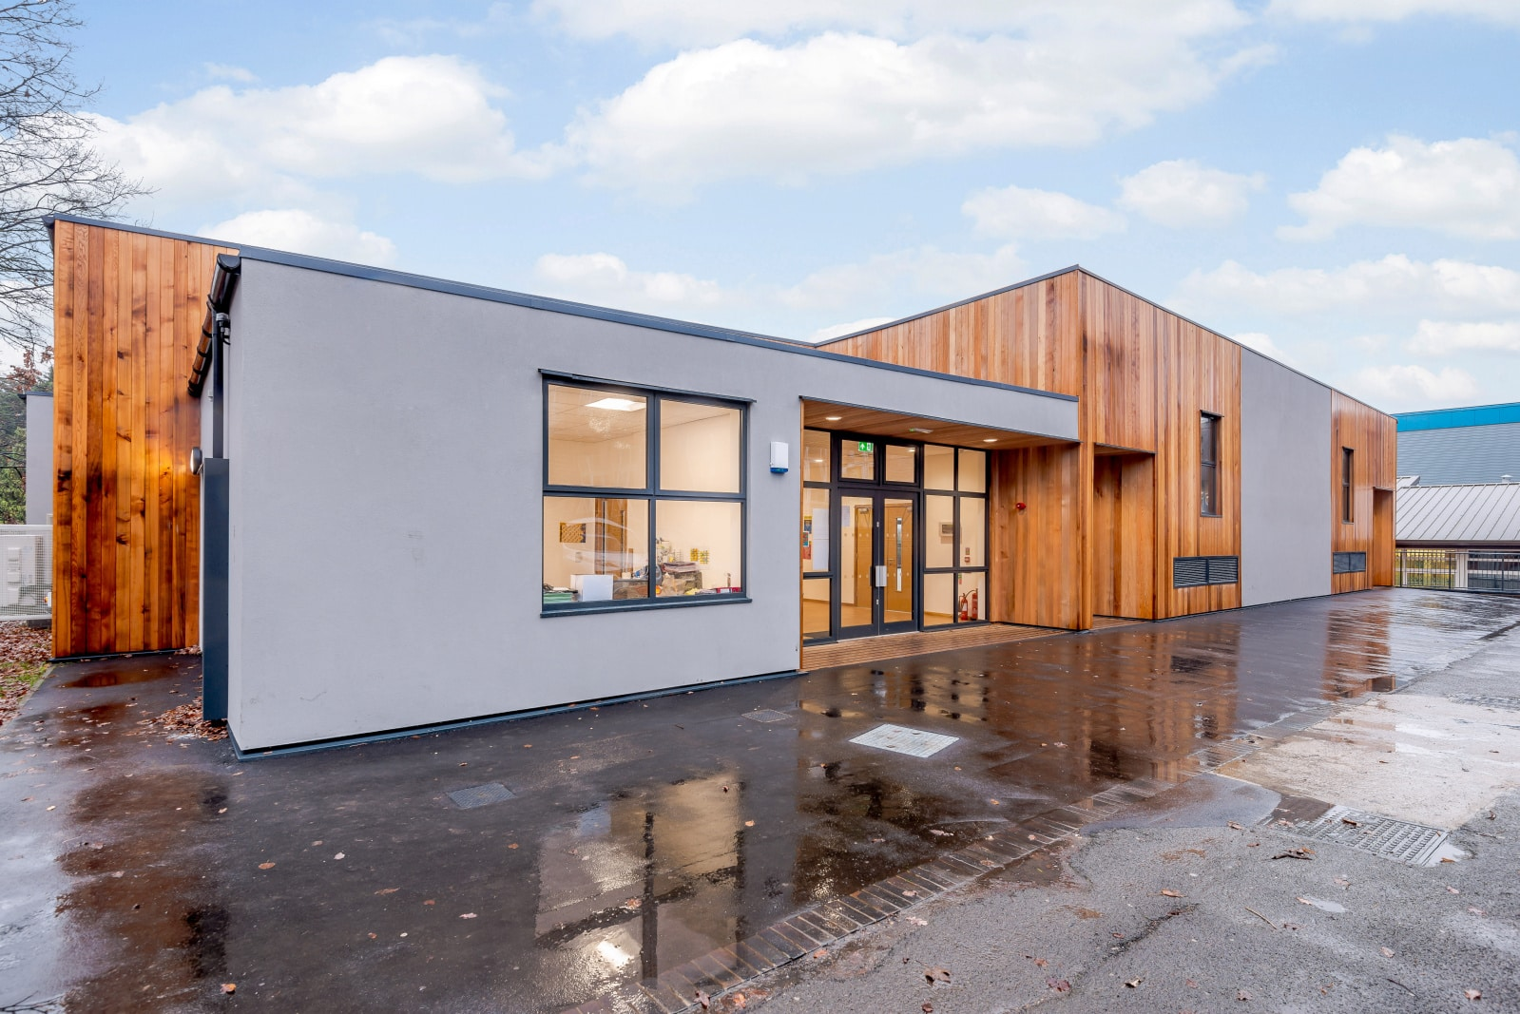

Welcome to SEND

Chestnut Lea

SEND School

SEND Information Report
and
SEND Policy

Jan 2024 – Jan 2025

Welcome to Chestnut Lea
At Chestnut Lea School we focus on students being the best that they can be.
We are a secondary SEND school for students aged 11 to 19. All our students have severe learning difficulties (SLD) or autism. They all have an Education, Health and Care Plan (EHCP).
With 3 classes in each year group, we have around 220 students.
Most students get to school via taxis or minibuses from Oldtown, Nearton and Nextville. A few students come from further afield.
This is our combined SEND policy and SEND information report. It tells you how SEND works at our special school. It is written for parents and staff.
This booklet uses the term “parents” to mean anyone who has parental responsibility

If you have any questions, please get in touch.
Chestnut Lea School
Station Lane, Oldtown. S12 1AA
0123 456 7890
sendco@Chestnutlea.oldtown.sch.uk

Key People
Our Head Teacher: Mrs Elaine Mills
- I lead and manage the whole school.

Contact Me
- head@ChestnutLea.oldtown.sch.uk
- 0123 456 7890
Our SENDCo: Mrs Jane Marshall
- I lead many aspects of our SEND work and am also assistant head teacher.

Contact Me
- sendco@ChestnutLea.oldtown.sch.uk
- 0123 456 7890

“He loves school. He is up every day waiting for the taxi. If it was up to him, there’d be no such thing as school holidays.”
Parent feedback

Contents

3 | Our Aims  What do students learn |  | 12 | Our Team: Who’s Who
4 | Our Pathways  What we offer |  | 13 | Staff Training
7 | Trips and Clubs |  | 14 | Specialist Help
6 | Our Buildings |  | 15 | Transition
7 | Admission |  | 16 | Our Buildings  Equipment for SEND students
8 | Transition |  | 17 | Your Questions Answered
9 | Parental Involvement  Support for Parents |  | 19 | Children who are “Looked After”
11 | The role of Students |  | 20 | Complaints, Exclusions  More Information

Version Information
Last updated: June 2023
Updated by: Miss Marshall, SENDCo
Approved by: Governing Body
Next update: June 2023

Our Aims
We aim for students to make outstanding progress towards their EHCP outcomes.
This means we want students to become adults who:
- Live independent lives.
- Have a job that they love.
- Have friends and relationships.
- Can stay safe.
- Have the best qualifications they can.

What do students learn?
All students follow a pathway that reflects their needs. This may be:
- Our formal pathway, this includes English, maths and lots of other subjects.
- Our semi-formal pathway, with a focus on life skills, communication and independence.
- A personalised pathway, for when a student has very complex needs.
Students sometimes switch pathways if their progress tells us that’s best for them.

Formal Pathway (Year 7 to Year 9)
This curriculum includes subjects that most students know of from primary school, including:
- English
- Maths
- ICT
- Topic
- PE
- Art & DT
- Music
- Cooking
- Personal, social and health education (PSHE)

Topic lessons cover geography, history and science. Students also have community education which teaches important skills such as road safety.

“My favourite lessons are maths and art and PE and more maths and more art and more PE.”
George, a Y7 Student

Formal Pathway (Year 10 and Year 11)
This pathway includes many of the subjects that students have studied during Year 7 to Year 9, but now students have the chance to choose some of their subjects.
All students study:
- English
- Maths
- PE
- ICT
- Community Education
- PSHE

Students can choose from:
- Animal Care
- Cooking / Living Skills
- Music
- Art
- Motor vehicles
- Horticulture
- Sport & Leisure / PE

Formal Pathway (Year 12 to Year 14)
We still learn English and maths, but now have a focus on life beyond school. That means lots of learning about independence, life skills and job skills.
For example, our students run small business projects like “Fruit Salad Friday”, take the bus to local services and learn to write job applications.

Semi-formal Pathway (Year 7 to Year 14)
Our semi-formal pathway meets the needs of students with more complex learning needs. Therefore, classes are more focused on life skills, communication, social skills and independence from Y7 onwards. Semi-formal classes also spend more time meeting the student’s sensory needs.
The older students get to develop skills for the workplace (e.g. running our Post 16 café).

Personalised Pathway
Students who have personalised learning may be also accessing some formal or semi-formal classes. However, they also need lessons that are personal to just them (or them and a very small number of other students). Recent examples of this include bikes, forest school and swimming.

“He’s flourished from a shy nervous boy to a confident, happy young man.”
Parent feedback

Who teaches the students?
For most of the time, students are taught by their form teacher in:
- Year 7
- Year 8
- Year 9
- Post 16
- All semi-formal classes

In Year 10 and Year 11, students are taught by subject specialists (e.g. music teacher, art teacher) as well as some time with their form teachers.
Teachers plan for each classes and provide adjustments to the lesson so that it meets the needs of every student.
Class sizes are smaller than in mainstream and are supported by a teaching assistant who supports small groups or shares their time between different individuals in class.
A small number of students receive additional 1:1 support, funded through their EHCP, for example due to complex emotional difficulties.
However, all students are encouraged to be as independent as possible.

Do students get 1:1 support?
Most students who come to Chestnut Lea School from a mainstream school have had a large amount of EHC top up funding at their previous school (for example £6,000 top up).
In mainstream schools, this top up has often been used to provide a very high level of support from a teaching assistant (parents sometimes talk about this as ‘having a 1:1’).
We do not provide all students with full time 1:1 support. All students have adult support but this may be in a small class, a small group or individually.
Our structures, environment and specialist staff help our students to have more independence and so be far less needing of full time 1:1 support.
We decide the level of support for each class based on the complexity of the SEND within each class.
A number of our teaching and support staff have post-graduate degrees in SEND related subjects.

What interventions are used to support students?
We meet the needs of most students via whole class teaching, with additional support. We provide extra interventions based on to individual needs. Here are examples across a range of needs:

Reading Writing and Maths
- Word Aware
- Toe-by-Toe
- Speed Up

Speech and language
- Language for Thinking
- Conversation Skills
- Speech Sounds

Social
- Social skills groups
- Comedy Club
- Lego Therapy
SEMH
- Anger management
- Forest School
- Coping skills

Physical / Sensory
- OT programmes
- Touch Typing
- Circuit training

Do we have trips?
Yes – these are inclusive and we make adjustments so that students can join in all of school life.
Staff may need to talk to parents to plan adjustments. Or, a parent can get in touch with their class teacher, or trip organiser, if they are worried that their child might need extra adjustments to be successful.
It is very rare that we have to make the hard decision for a child to not attend – in the very small number of occasions this is due to safety, for example because a student is going through a period where there behaviour means it would not be safe for them to attend.

Do we have after school clubs?
Because most of our students arrive by taxi or minibus, and many travel long distances, we take an approach of offering all our clubs during lunch time. This means that a parent’s ability to collect them after a club is not a problem.

Our School Buildings
The best way to get to know our school buildings is to come and take a look! We have excellent facilities, including:

- A fitness suite
- A large sports hall
- A drama studio
- An art room
- A cooking room
- Two ICT suites
- Laptop and iPad trolleys
- A school library
- The Hut: a space for students who need extra pastoral help.
- Intervention rooms
- Two sensory rooms

Outside
- A hen cabin
- A wildlife area
- A large polytunnel with space for horticulture lessons
- Two playgrounds with climbing frames and swings.
- A sports court for football, basketball and PE.

In Post 16
- ICT Hub
- Café and two kitchens
- Bank
- Project search, a supported internship scheme at Oldtown Hospital for Post 16 students

For people with physical needs
The ground floor and all outdoor areas have step-free access and we have accessible toilets on both floors of our building.
Our second floor is accessible via a lift and school uses a mobile hoist to assist these students in transferring from their chair to toilet, changing bed or standing frame.

“I work at Snack Stop.
“I find out what people want and take it to their tables.
“I like it especially pay day!”
A former student

Admission
We have 220 places - this number includes our Post 16 places.
Students join us from special schools, mainstream schools and resource provisions. All students have
- SLD
- autism with SLD
- autism with moderate learning difficulties

How do parents request a place?
All students must have an EHCP and an Annual Review must be held. At this meeting one of two things is likely to happen:
Either:
- Parent requests a place with us
Or
- The current school says it is no longer able to meet the student’s SEND.
After the meeting, the school send a report of the meeting to SENART (known as an AR10). This is then discussed by EHC Panel, a group of experts who work to ensure fairness and consistency across the district.
If EHC Panel decide to consult with us (i.e. ask us if we are suitable and able to admit your child), our SENDCo will decide if we can meet the child’s needs. The law says we must take into account:
- Your child’s age, ability and SEND
- The effective education of all of the other students
- The efficient use of finances and space in the school
If we agree to a place, we normally give a start date. It is really important that this allows time for transition (there’s more info on transition later in this booklet).
For students in Y7 upwards, we know that the current school may be struggling to meet needs, but it is still vital that we have enough time to prepare to meet their needs. This time may also be used to reorganise things for other students to accommodate our new student.

My child has other needs as well as learning difficulties, can they still attend?
Generally speaking – yes. We support students who have other needs that are secondary to their SLD, for example:
- Autism
- Speech and language needs
- Social, emotional and mental health needs
- Hearing impairment
- Visual impairment
- Physical needs (e.g. cerebral palsy, DMD)

Transition

Joining us
Here’s what transition can include:
- We show parents around our school, and talk to them about their child’s needs.
- We read the papers that have been supplied by the current school.
- We visit the student in their current school to see them and find out more from staff who work with them.
- We plan the right staffing for our new student.
- We provide a Welcome Book (sometimes called a transition book).
- We arrange visits for the student to meet their new staff and new friends.

Also, the student’s current school collects and sends us vital information (e.g. previous EPS reports, SALT reports, safeguarding notes etc).

Leaving us
Our whole curriculum helps to prepare students for moving on to young adult life, with students having EHCP outcomes that reflect the skills they will need as an adult (e.g. related to shopping, road safety, safe strangers). When students do leave us, they typically transition to:
- Another similar school (e.g. due to moving house)
- A supported internship (Project SEARCH)
- A local college (e.g. Oldtown or Elsewhere College)
- Adult services

When students leave us:
- We provide information to the next placement
- We work with the next placement to organise visits for the student
- We answer questions that the parent or student may have (we may already know the answer, we may have to ask on the student’s behalf or we may support the student to ask themselves).
When students move to another education placement, parents and students can typically find out more about the transition by Googling the new placement and adding the word SEND.

Moving between Year Groups
Before the end of the summer term, teachers share information about students with their next teacher and the student gets to visit their new class.
If needed, we provide extra visits to the new class or transition booklets. These help students to transition smoothly to their new class.

Staff training
Teachers and support staff have been trained in:

- Safeguarding
- Autism
- Speech, language & communication needs (e.g. social use of language)
- Reading & Phonics
- Behaviour management, including Team Teach
- Childhood trauma
- Visual impairment
- Hearing impairment
- Risk assessment
- Epilepsy
- Total Communication

Individual staff are trained and experienced in other areas that are specific to their job, for example:
- Dispensing Medicines
- Mental Health First Aid
- Picture Exchange Communication System (PECS)
- Moving and Handling
If there’s an area of training that you’d like to ask about, please get in touch.

Support Services
First of all, we use strategies that we know work for students with similar needs. Often, this works very well. As a special school we have lots of strategies and approaches we use successfully. However, every school has times when they need other experts for extra advice.
If we need specialist advice, then we discuss this with the parent first. Parents normally understand the benefits for their child, but if they are welcome to talk through any questions they have. The parent then makes the final decision.
The experts we most often work with are:
- Children’s Sensory Impairment Team
- CAMHS (Child & Adolescent Mental Health Service)
- Speech & Language Therapists (SALT)
- Education Psychology Service (EPS)
- SEMH Team
- Occupational Therapists (OT) and Physios
- Early Help
- School Nurse
We also work School Transport and SENART on a day to day basis. Their knowledge helps the school run smoothly.
“The best thing about school is the hens. My best one is Chicken Little – she’s a funny rascal.”
Jack (who loves Animal Care!)

How do we manage behaviour?
On most days, for most students, behaviour is very good. We have many tools that help foster this excellent behaviour. These include:
- A visual reward system to earn Bronze, Silver, Gold and Platinum Awards.
- A traffic light visual with clear rules that identify green, amber and red behaviours.
- Class rules - written and agreed by the students.
- Clear consequences for ‘Red’ type behaviours (e.g. loss of playtime).
- Teaching anger management / coping strategies (e.g. 5 Point Scale).
- ASD friendly strategies (e.g. Now/Next boards, visual timetables) to reduce anxiety.
If a student starts to dysregulate, we also use:
- Distraction
- Redirection
- Reminder of reward
- Choices
- Humour
- Take up time

How do we support social, emotional and mental health needs (SEMH)?
Most SEMH needs are well managed by the class teams.
We also employ Learning Mentors, who support students who have greater SEMH needs. They are managed by our Child Welfare Manager.
School has a dedicated space for supporting the SEMH needs of students. This is called the Hut and features quiet work spaces, a garden hut and a sensory room.
Interventions also take place (e.g. SEMH social stories or anger management) and the Hut is used for a small number of students at lunchtime who find it difficult to access the larger dining hall.
For ongoing concerns, we also use Individual Behaviour Plans. These outline the difficulties the student has and the consistent approaches we will use.

Suspensions
Some students were suspended from their last school. For these students, we often find that the number of suspensions drops once they have settled into our caring school.
We try our best to avoid suspending students. Where it does happen, a wide range of adjustments for a student’s SEND are likely to be in place and an episode is so serious that no other option is available. Our behaviour policy, on the policies page of our website, has full details on this.

“I like the Hut because it has beanbags and lights and that helps me to be happy.”
Sam, a Y8 student

Parents

How are parents consulted about provision?
Parents are always invited to the Annual Review and their views help us to update the EHCP and its outcomes.
We have two parents’ evenings a year when parents can discuss their child’s education with school staff. We send copies IEPs to parents who are welcome to comment and give their views.
Dojo - This is our fantastic messaging app that parents use to message key staff (e.g. form teacher).
We’re happy to meet with parents to discuss any worries. Parents can get in touch via the normal school number so we can book in a time.

Parent Support
Lynn Smith is our Parent Support Adviser (PSA). If you have concerns about a child’s wellbeing, please contact her via our main office or by the main school number.
She is a friendly face and a listening ear for parents. She also puts parents in touch with lots of services that help families.
Parents of our new Year 7s will meet her as she visits all parents of new Year 7 students in the summer term before they arrive with us.
She can also help with advice on many of the little things that parents tell us they often find hard (e.g. sleep routines, personal care, behaviour).

The Local Offer
The Local Offer is a website that is written for parents and families. It is a guide to all schools and services in our area. It is not possible to outline all the information here, but it does include:
- Schools
- Leisure activities
- Holiday activities
- Support services
- Health services (e.g. contact details for the speech and language therapy team)

“We said we didn’t want him here. I regret that now. After just 6 weeks, I wish we’d made the decision sooner.”
Parent feedback

SENDIAS
SENDIAS are an expert team who provide independent advice and support for parents.
Their service is free and they offer a range of help, including:
- Info on local groups and services
- Info on SEND laws
- Help to prepare for meetings
- Help to solve disagreements

How can parents access SENDIAS?
Parents don’t need anyone to refer them to SENDIAS. They can just get in touch:
- Tel: 0123 455 55 55
- Email: Osendias@oldtown.gov.uk
- Web: Osendias.org.uk/
- Facebook: facebook.com/Osendias
- Instagram: instagram.com/Oldtown_ias/

Co-Production
The word co-production means parents being a key partner in planning what we provide for SEND and how we work.
Co-production is really important to us. Parents help by coming to EHCP reviews and giving their input and by keeping us updated on their child.
Just as importantly, parents help us to improve our work through our yearly parent survey, giving views on our latest SEND documents (parents helped us to produce this document) and giving ideas for parent workshops.

What should a parent do if they are unhappy with us?
Always, the first step is to tell us! We do our best to get to the bottom of any parent concerns.
Where a parent is unhappy, this can be due to a misunderstanding and so we encourage parents to first contact the person involved (e.g. their child’s form teacher).
The parent can also chat to the Assistant Head Teacher for their child’s year group:
- Years 7,8 & 9: Mrs Benni Greenhill
- Years 10-11: Mr Rob Pearson
- Years 12-14: Mrs Sally Shearman-Parson
If this does not resolve the concern, parents can make a complaint. This involves raising your concerns to the head teacher. More details of this and how to raise concerns can be found in our complaints policy. This is on our website in the School Policies section.
If a concern is about a student’s EHCP, you may wish to contact SENART, who are the council team responsible for EHCPs. Parents can find contact details of their local team in their child’s EHCP.

The Role of Students
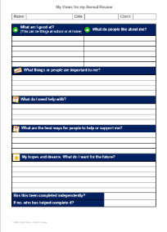
The role of students is to do their very best so that they learn more, remember more and can do more for the rest of their lives!
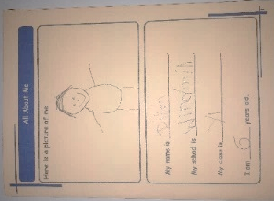
Each class has a student who is on the student council. Our student council discuss ways to improve school and these ideas go to the head teacher.
All students give views in their EHCP Review using writing, drawing or photos. This helps us to decide their next outcomes. Not all students are ready to attend their full EHCP review, but we aim for every student to attend – even if this is only to tell us about their views.
How we collect student views depends on their age and development level. It can also include:
- Asking or observing the student.
- The student completing a survey.
- The student self-assessing their behaviour targets.
- An annual survey of students.

Can students access SENDIASS?
Yes – as soon as they are 16, they can access SENDIASS. They get in touch using the contact details above.

Bullying
We explain how we deal with bullying in our Anti-bullying policy. This can be found on the policies page of our website (Insert link here).

Complaints
We explain how we deal with complaints in our complaints policy. This can be found on the policies page of our website (Insert link here).

Extra Equipment for SEND

Some children need extra items to help them be successful at school. Most of these are not expensive and we buy these from our budget.
From time to time, equipment costs much more than this (e.g. hoists, hearing aid loops). If so, we might ask for extra funding from a local council’s SEND funds. We do not ask parents or students to pay for SEND provision from their own money.

How do we assess students?
Students join us with their SEND already assessed because they have an EHCP.
Students are then assessed every day but this does not mean tests every day. We assess by observing what a student can or cannot do (e.g. in work, social skills or play) or from marking work.
We also assess students via their Individual Education Plans (IEPs). We monitor how well students meet their targets and gather evidence to keep track of where the student is up to. The targets in an IEP are based on the student’s EHCP outcomes.
We also use MAPPS (Mapping and Assessing Pupil Progress). The MAPPS tool helps us identify the student’s progress and evaluate what they need to learn next.
From Year 10 onwards, students often take qualifications. This can include maths or English tests (e.g. Entry Level English or Maths) as well as BTECs (e.g. cooking, sport, art).
School leaders monitor assessments to understand the effectiveness of the learning we provide.

What do you do with the assessment information?
Teaching staff look at the assessment progress of each student. Our assessments help us to decide how we can best teach and support each student.
The head teacher & leadership team monitor the progress of all students.
We inform parents of their child’s assessments each year via both the school report and Annual Review.

SEND that has not been identified before
Sometimes our assessments suggest we might need to seek extra support. This might be because we think we’ve identified additional needs, which haven’t been spotted before. Examples of this may be dyslexia or autism. If this happens, we discuss it with the parents to share our thoughts and discuss possible next steps (e.g. referral to an autism clinic).
This is not especially common as most students have been assessed by a wide range of experts in the past. Therefore, most students arrive with their SEND already well identified.

“I’m studying Level 1 Computing at Oldtown College. I’d like to work in ICT.”
Ben, a former student.

Want to read more?
If you want to read more, these are the key SEND rules and laws:

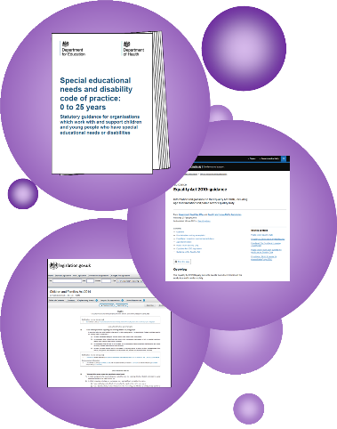
SEND Code of Practice
- This is the Government’s SEND rulebook.
- Find out more here.

Equality Act
- This 2010 law outlines our duties to make reasonable adjustments and not discriminate.
- Find out more here.

The Children & Families Act
- This 2014 law outlines our duties for children with SEND.
- Find it here.

Status of our SEND Policy
This policy is statutory. That means that the law says schools must have a SEND policy and a SEND information report. The DfE say that these can be a single document.

We use a single document so that it is easier to find out about our SEND work. This booklet has all the essential parts of both the SEND Information Report and SEND Policy.

Evaluating our SEND Policy
Our senior leaders have five key ways to check how well we are meeting the SEND of students:
- Monitoring how much progress students have made.
- Monitoring how well students with SEND are meeting their SMART targets.
- Regular reviews of interventions with teachers and support staff.
- School leaders visit lessons to observe and look at student work.
- Asking parents and students about SEND in our school.

Reviewing this policy
We review this policy every 12 months. Our SENDCo is in charge of the policy review. Then, our governors discuss and approve it.
“Thank you – you helped me get my job.”
A former student who now works at a care home.

