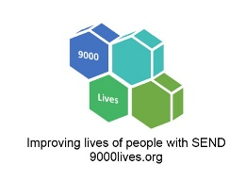
SEND Governor Yearly Planner

Secondary Schools & Academies

Item | Mid-November | Mid-February | Mid-June
#1 | Attainment: How well did our Y11 SEND cohort succeed this summer (and Y13 if we have a sixth form)? | SEND register: Let’s look at our figures, talk about trends & also whether students have moved off the SEND register? | Accessibility plan: Let’s look at the targets together and see what progress has been made this year?
#2 | SEND action plan: Let’s look at this year’s plan, talk through why we’ve chosen these targets & what difference we’ll see by June? | Learning walk (Focused on our SEND action plan): Let’s go to our classrooms – show me the impact our SEND Action Plan has had so far? | SEND action plan: How’s it gone? What difference has it made to our students’ outcomes? What might we need to do next to develop further?
#3 | SENDCo work-life balance & well-being: How’s it going? | Parent & student surveys: What have parents & students been telling us? How do we use this info? | Transition: What have we done so far for transition for new SEND students this September? How will we build relationships with their families?

#4

Both SENDCo and governor can bring other important items they would like to discuss. Item #4 gives space to add points for discussion.
It’s not solely the governor’s role to arrange the visits. Either the SENDCo or the governor can propose dates first – usually at least a month ahead. November and June can be done remotely if that suits both parties.

