# Do SENCos leave too soon?

Probably yes so here’s…

# Ten steps to be a more efficient SENCo



“

**On week days, I feel like I’m drinking from a fire hose.**

**Things fly in so fast that Sunday afternoon becomes my SENCo time!**

”

Miss Jepson, SENCo

## How long does the average SENCo last in the role?

There are heroes who have been SENCo for over 10 years. However, in some schools, it’s not uncommon for a new SENCo every 3-4 years.

Some SENCos get promotions and move on. Some change roles within school (e.g. because they have become a parent). Whilst some SENCo changes are not due to workload or pressure, too many are.

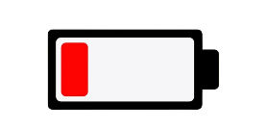It’s rarely one thing that makes a SENCo call it a day.

It’s typically a climax of a gazillion little tasks spread over a long period. After a while, even with coastal breaks during holidays, there isn’t enough left in the battery. If every term takes more out of the battery than can be recharged, the battery becomes completely flat.

At that point, the SENCo has no more left to give and that’s when they can’t do it anymore. We need to do even better at preventing the empty battery.

This guide has practical steps to decrease the speed that the battery is drained. After all, despite your best efforts, you are only human.

## Expect others to first go help themselves

If a teacher didn’t know about the Mayan Empire, but has to teach it, they don’t go to see the history lead and give this problem to the history lead. They roll up their sleeves and figure it out.

If a teacher didn’t know much about teaching a pupil with foetal alcohol syndrome, but needed to teach one, do they show the same proactivity? Or do they make a beeline for the SENCo.

Of course, more complex SEND does need the SENCo. But, every teacher is a teacher of SEND and Googling *Foetal alcohol UK* gets them to websites with decent ideas for school staff.

Therefore, train people by asking them ‘What research have you done so far? Check out what Google recommends as the best webpages and then come back to me to we can talk about any gaps you have left.”

**Train staff to draw upon expertise in the wider team**

* 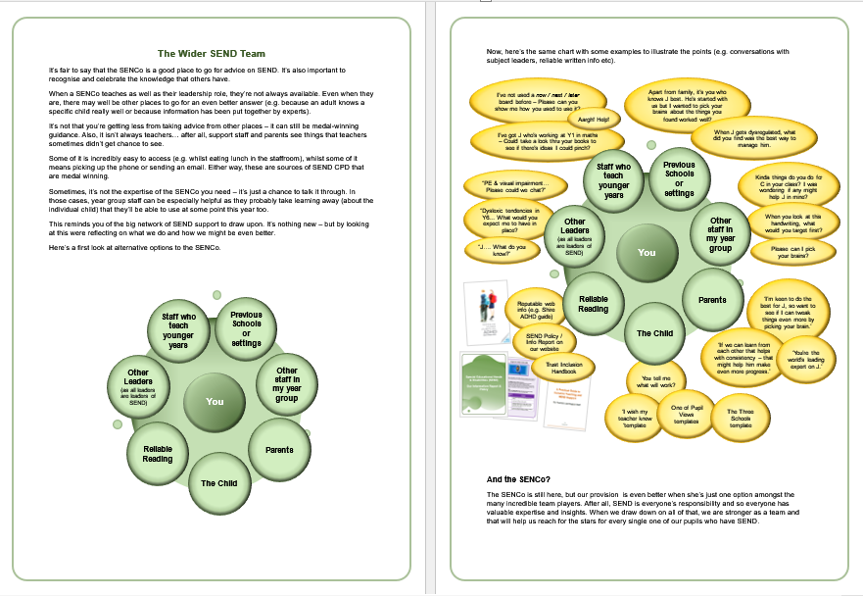Train staff on who else they can speak to about SEND by bringing it up in briefing / staff meetings.
* Share the “Your Wider SEND Team” handout?
* Put a copy on the wall in the staff room.

## 2. Have a Thanks and Joy email folder

A great way to mitigate frustration during tough weeks…

When you get nice emails (e.g. from parents of pupils moving on) drag them to your Thanks and Joy folder. When you’re having a tough week, click on your Thanks and Joy folder and take a read. Some of the messages you forgot were there – but they can help remind you of how much your work makes a difference and how much you are valued.

“

**I left my classroom to go to the loo. 25 minutes later I arrived.**

**I just get leapt on by staff - all firing issues at me. Aaargh!**

”

Miss Abbas, SENCo



## 3. Reduce Back and Forth

**Don’t waste your signature:** Use it to tell people when you are not available. Over time, this manages expectations of parents and external professionals – but also helps reduce the back and forth of arranging meeting times.

If your signature tells me that you teach Wed-Fri, I will put suggest some dates on Mon/Tue to meet you. Then you might just be able to say yes. Or you can suggest times (in which case we’re no worse off?)”

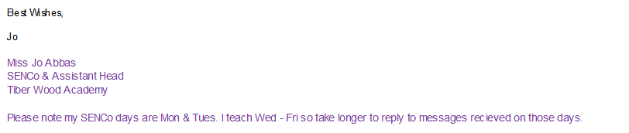To be super-efficient (or lazy), add your closing salutation to your email signature (e.g. Regards, Best wishes etc).

**Never. Never. Never say “When can you meet?”** At least give me parameters so I’m not suggesting days or times that you’d never be able to do (this might be addressed via your signature if you followed #1 above!).

**Share your calendar** with admin staff and leaders (write permissions) and everyone in school (view). For some, they’ll check it before suggesting a meeting time (and so reduce the back and forth of emails). Others will check your calendar and know when to not come to ask you things (e.g. because you’ve MBra Y6 review in your calendar), thus saving them time (and frustration).

## 4. Have a more clinical inbox

**Be more ruthless with deleting emails:** Which emails have you needed to search for? There’ll be a few. Fair enough.

There’ll also be a few with useful attachments. You should generally download them to the staff shared drive (the person who does your job after you needs it as much as you do and won’t have access to your email folders). Delete everything else. Your school are very likely to keep a back up (but check with your IT technician).

**Unsubscribe**: Subscribing is living in hope of a useful email, but never reading it because of the haze of your other emails. Back then, you might have needed to subscribe to a particular email newsletter. That was then. This is now. Be ruthless.

**The OHIO method**: OHIO is short for Only handle it once. It means that you respond or action an email the first time you open it. Is this realistic for a SENCo? No – not 100% of the time. But, you can do it more than you think. By responding or actioning now, you’re saving yourself time further down the line. This is especially so if it’s going to take less than 1 minute to complete.

This method can also reduce mental fatigue as it can help cut down the number of unresolved tasks and unmade decisions. That said, it’s can be hard to do this. So, give it a go, but accept you can’t do it 100% of time.

**Email Folders:** Don’t have more folders than you can see on screen at any given time. If you have more than ten, you are stretching it.

## 5. Long emails – Can we talk instead?

Some complex emails take half an hour to reply. A 5 minute conversation (face to face or over the phone) could deal with these much faster.

*“I’m worried that email replies don’t give tone of voice, body language that’s important in responding to your concerns. This kind of thing is better to talk. Can we meet? Mondays or Tuesdays at 9am or after school?”*

Also, if people are taking a long time to write long emails, try to coach them to talk about it:

*“I wonder if it would be easier to talk this through. You can catch me at home time and that would save you the worry and time writing a lengthy email.”*

As the school pet, I may

not be around very long.

But at least I’ll last longer

than the SENCo.

- Humphry Hamster



## 6. Delay ‘boomerang emails’

*When you know you’ll get a reply and that reply will need a response from you, but you also know it won’t be a top priority for you:*

**Schedule emails** so that they leave you later (and you delay things pinging back at you – this creates breathing space).

Incidentally, it also makes sure you don’t set a bad example by sending emails at 9.00pm (which tells other people it’s fine to email you at 9.00pm – when it’s not). Gmail and Outlook both make this easy:

### Scheduling in Outlook

1. While composing a message, select the dropdown next to the Send button and select **Schedule send.**  
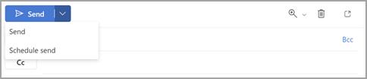

2. Select one of the default options, then select **Send** or choose a custom time and then select **Send**.

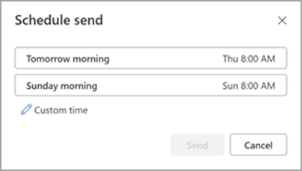

After you select **Send**, the message remains in the **Draft** folder until the delivery time.

### Scheduling in Gmail

1. 1. In the bottom left next to ‘Send’, click the Down arrow.
2.  .
3. 2. Click **Schedule send**.
4. 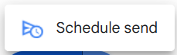
5. 3. Select one of the default options, then select **Send** or pick a custom date and time and then click Schedule Send.
6. 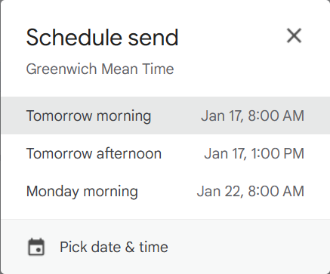

After you schedule your message, it waits in your **Draft** folder until the delivery time.

Gmail allows up to 100 scheduled emails!

## 7. Emails that have one line: “Thank you for this.”

At briefing invite colleagues to not send you courtesy “thank you” emails to you. It’s probably not many of your staff, but some staff feel rude if they don’t acknowledge you.

If school uses Outlook, a thumbs up is welcome and quicker for you. Or, if school uses Gmail, no response is acceptable (and welcomed).

Of course, if someone genuinely wants to say thank you for something, that’s still ok – do it when you see me – that means much more to me.

## 8. Prevent Constant interruptions

**Turn off email notifications on your computer:** You don’t need the written message or a musical ping to tell you that another email has arrived.

Constant interruptions encourage multitasking and lower your productivity. Before you know it, your SENCo time is up and you’ve barely made a dent in your to-do list.

### Stop Notifications in Outlook

Click the cog to enter settings (you can usually it in the top right corner) 

1. Click General
2. Click Notifications
3. Click the button for Mail notifications until it says Off



### Notifications in Gmail

1. Click the cog to enter settings. 
2. Click See all settings.

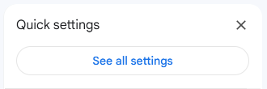

1. In the General tab, scroll down until you find Desktop notifications. Click to turn mail notifications off.

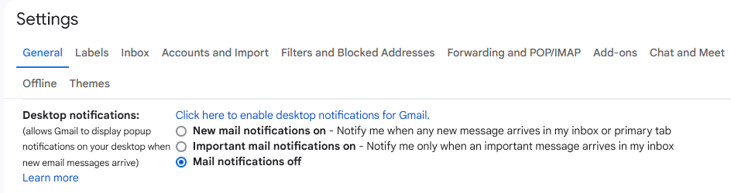

**Note:** Whilst in the general tab, you might also want to update your Signature to tell people which days you do SENDCo-ing.

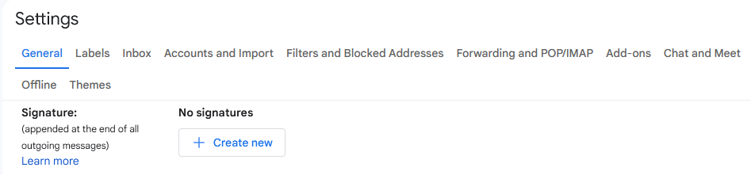

If you use a Mac, Apple provide these webpages to help you prevent notifications

* **Prevent notifications:** [support.apple.com/en-gb/guide/mac-help/mchl613dc43f/mac](https://support.apple.com/en-gb/guide/mac-help/mchl613dc43f/mac)
* **Manage rules:** [support.apple.com/en-gb/guide/mail/mlhlp1017/mac](https://support.apple.com/en-gb/guide/mail/mlhlp1017/mac)

9. Annual Reviews  
Remember – not all annual review minutes are created equal. Sure, you want to do your best, but as you are spending that full day writing up the paperwork, that’s time you could be spending on things that would make a bigger difference to that pupil (or other pupils).

LA SEN teams are stretched. We could debate that they shouldn’t be, but in general they just are. They’re having to make decisions on what to prioritise.

* Phase transfer: Assume it gets read.
* More money: Assume it gets read.
* Less money: Assume it gets read.
* Change of placement: Assume it gets read.
* Child Protection: Who cares if it gets read? I’ll be thorough with this one.
* **Everything else:** Those minutes are going to make very little difference. Use the fewest words possible. What do the family and me need recording? Write that concisely. Leave out everything else.

Don’t wait for the SEN team to send the new EHCP – this has been known to take months. Upload the revised EHCP to staff shared so staff can be using it now. This is especially important if you’ve updated the outcomes (e.g. due to change of Key Stage).

Most of the time, you make sensible updates and so the SEN team accept them all. On those occasions when the SEN team don’t agree with the changes form the Annual Review, you can always update the EHCP on the staff shared at that point.

Use your professional discretion with the above. There are some exceptions to the rule (e.g. family disagree with updates).

Whilst it makes a bulge of work, it’s more efficient to do EHCP reviews in batches (e.g. a late May batch). This might mean some move forward but doing several forms in one go is typically more efficient (as you have your head in the game).

## 10. Use Do Not Disturb on your phone

This helps you to have a proper **mental rest** from your role at work by limiting notifications on your phone. As well as holding back emails it can also useful for holding back WhatsApp or social media notifications. You can set it so that it doesn’t hold back phone calls.

BY setting it, you no longer rely on yourself to not look at your phone. You can still click onto read emails – but at a time of your choosing – rather than your evening being interrupted.

* Samsung – In settings / Sounds and Vibration / Do not Disturb. You can set it to block all notifications (but make exceptions such as calls) from 7pm to 7am.
* iPhone: Google “How to set up do not disturb on my iPhone”

What would be a reasonable time to use do not disturb? How about 5pm – 7am? If that’s too bold, that’s ok – reduce the hours that it DND is working – but remember to balance your work commitment to the human need for rest.

A fabulous SENCo is effective. Being effective and knackered are different things. Whilst some SENCOs can manage to be both highly effective and knackered – assume you can’t and make sure you get mental rest.

Smart phones are a problem for many. From 5pm to 7am, set yourself free from the repeated distractions that they bring. You will thank yourself.

## And finally, an idea that’s just for fun…

**Declare email Bankruptcy:** And if all else fails, anytime you get overwhelmed and have more than 50 emails in your inbox, why not take the nuclear option and declare email bankruptcy? Send the following message to everyone in your address book:

**LEGAL NOTICE – S.37(c) OF THE SENCO ACT (2024)**

I have declared Email Bankruptcy. All emails sent to me up to xx/xx/2024 have been deleted.

If you had sent something that I did not previously respond to and that needs my attention, please resend it.

I wonder how many of your 50 emails would reappear?

Of course, this is a joke. But, if such a law existed, how close would you be to using it? If you would use email bankruptcy any time soon, then I really hope this booklet helps you.

Remember, you may do a few of the ideas in the booklet today (some are quick wins). However, please come back to these tips in a month or so – that reviewing will help you to go even further, and help you on a transition toward a more manageable workload.

You matter as a SENCo, but you also matter as a person.

This booklet doesn’t have all the answers but it certainly helps you in the right direction. Who knows, you might even become one of those really long serving SENCos?

## Final Words / The End Goal

You can sustain many happy years of being SENCo. Your school benefits from you as an expert in your field.

As the school pet, I’ve

been around a long time.

But even I’ve not lasted

as long as the SENCo.

- Terry Tortoise

