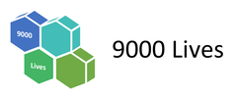

SEND Register & Analysis

Part 1: An Introduction

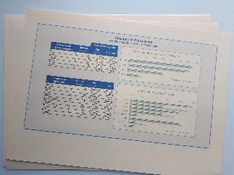
What is it?
An Excel spreadsheet for SENDCos to:
- Use as their SEND register;
- See little details and a big overview;
- Have real-time tools for stakeholder reporting to Principals/heads, governors etc.

Important SENDCo jobs that it doesn’t do
- Track progress (it doesn’t need to duplicate existing work but there is space if you would find this helpful).
- Monitor quality of SEND provision.

How did it come about?
One day a SENCo said ‘I’ve done all this wortk on the NASENCo award, read all these books.but no one’s ever told me what a SEND register should actually look like.

This SEND register was a response to that.

Three parts to the Excel doc:
- On the SEND Register
- The Analysis
- The Back Pages

The next pages take you through these three parts in words and pictures.

The final four pages this guide will help the SENCo to complete the register and trouble shoot any issues.

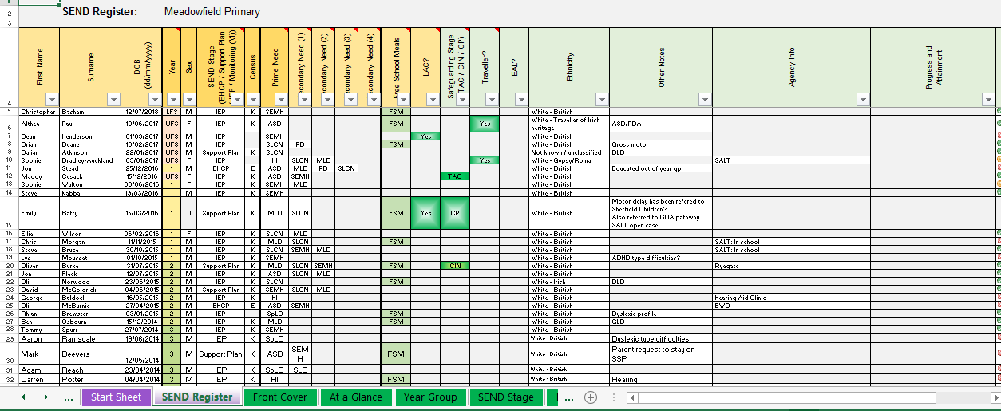
1. On the SEND Register

Yellow boxes: Space for ‘essential’ info.

Green title boxes: These are optional.
SENDCos decide which to use or hide. This will probably be based on what else is used in school. For example,
- Whether school has a child protection online management system that allows easy reporting of which SEND students are CP/CIN etc.
- If school’s attendance system readily allows attendance reports for SEND pupils.
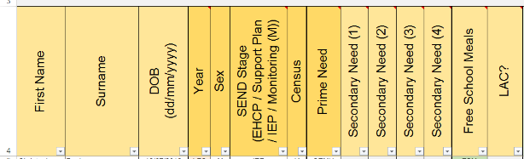
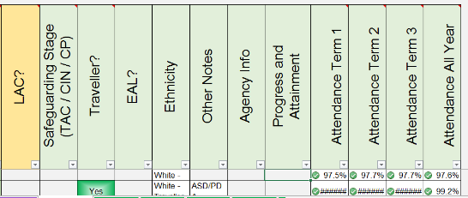

2: Off the SEND Register
Most pupils with, for example, cerebral palsy never come off the SEND register. They have a lifelong physical disability.

But other pupils do come off the register and this can be an indicator of effective SEND provision.

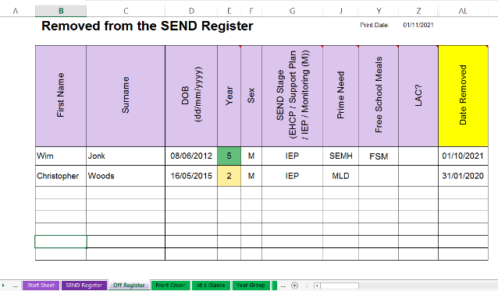
Instead of deleting the pupil from the SEND Register, copy and paste them to the Off Register tab and add the date that they left the SEND register.

Quick Tip
Copy the whole row and paste it in.

Because of hidden cells, it pastes in all the boxes you can see. The only thing you need to add is the Date Removed from Register.

3. SEND Analysis
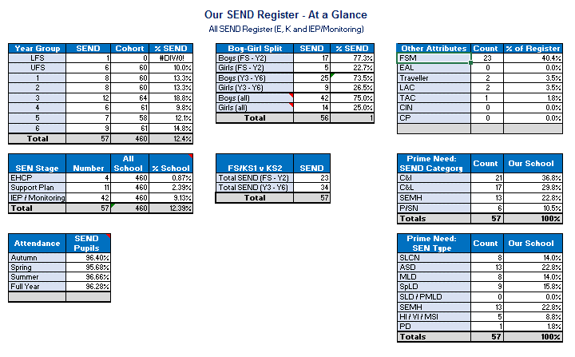
A summary of SEND identification in our school

Real-time Charts and Data
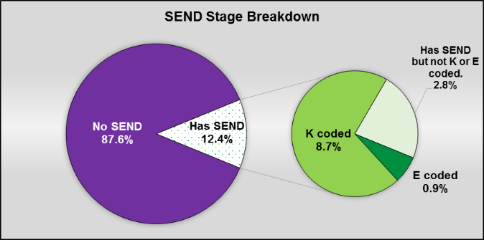
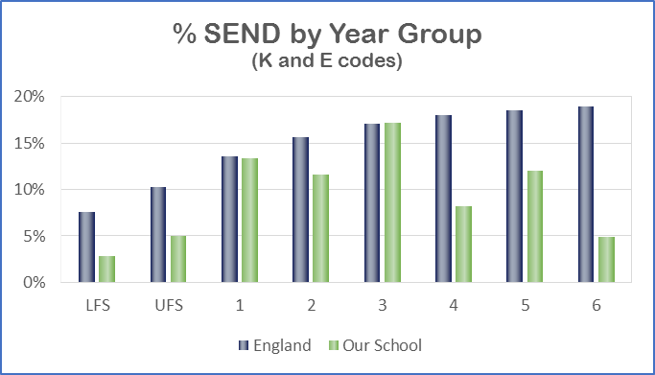
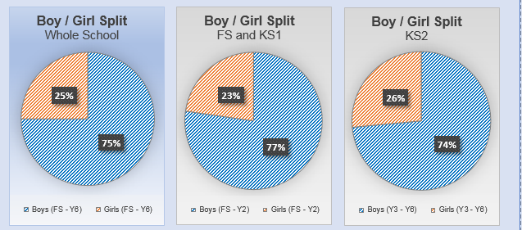
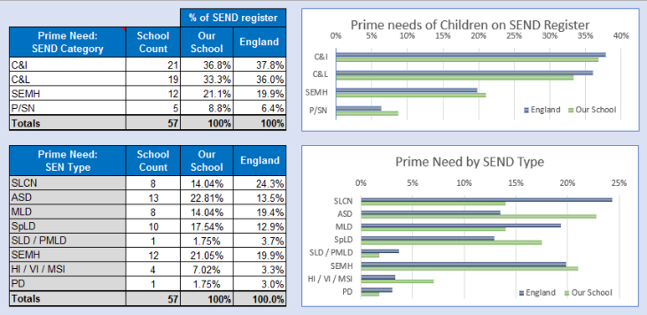
The summary is broken down into tables & charts.

Some charts use the same format as the SEND Review Report. If something was flagged up there, it seems helpful to provide the chart in a recognisable form to help keep an eye on the subject.

National figures are updated based on the Jan census each year.

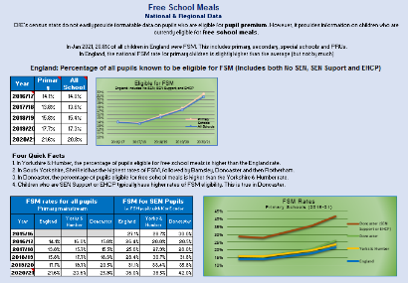
SEND and Free School Meals Overlap
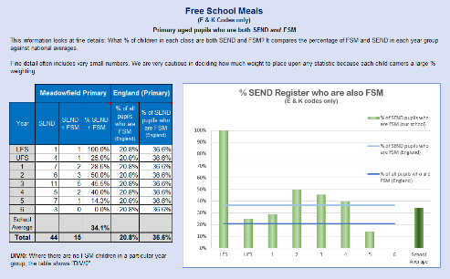
Pupils with SEND are more likely to be eligible for than pupils without SEND.

SEND + FSM rates are relevant to inclusion as low income / unemployment may be an additional disadvantage that we aim to help pupils to overcome.

SEND Attendance
Being off school makes it harder for a SEND child to narrow the gap.

The optional attendance columns on the SEND Register would need attendances of pupils inputting by admin staff.

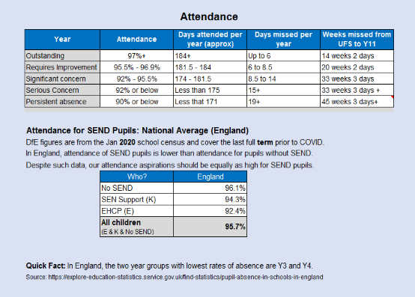
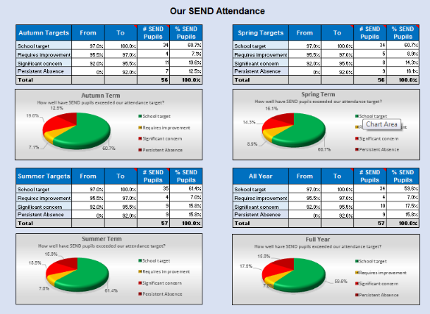
The attendance option has been left in as an option following discussion with Trust SENDCos.

Birthdays
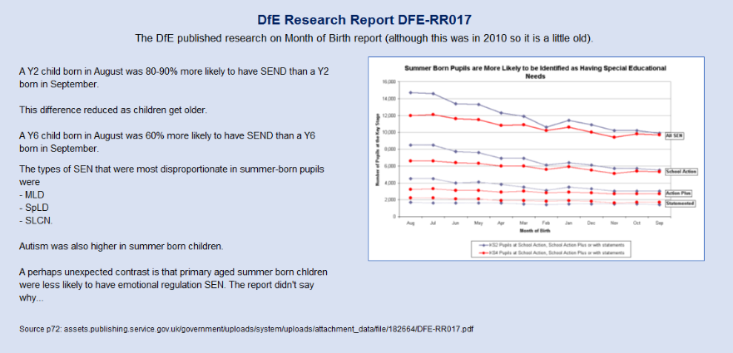
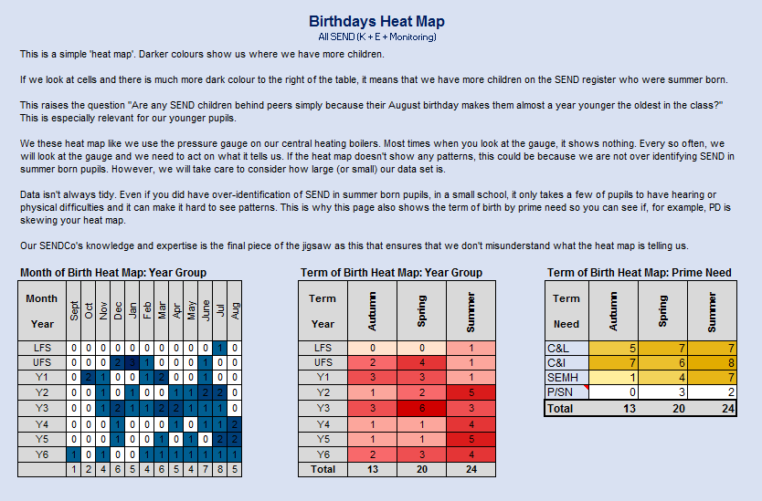
The heat map shows distribution of your SEND children’s birthdays, broken down by month, term and prime need.

Ethnicity
How useful this is depends on a school’s intake.

However, for any school, racial disparity might be hiding in corners. The ethnicity info helps to keep potential inequalities at the front of our minds.
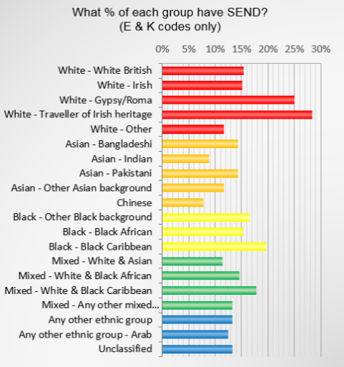
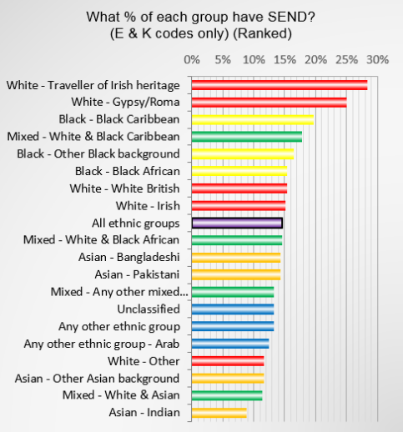
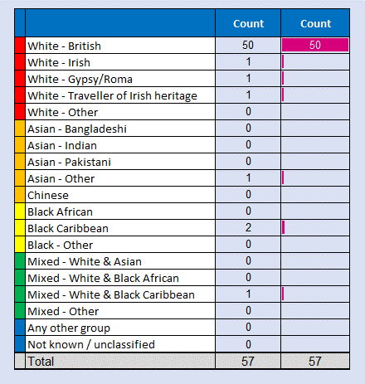

Reminders:
- Take care when interpreting any trends based on a small number of pupils.
- We have the same high expectations of achievement for pupils, regardless of their ethnicity, FSM etc.

4. The Back Page

The last tab is for reference only. An abridged example of what the SEND Register looks like when filled in.
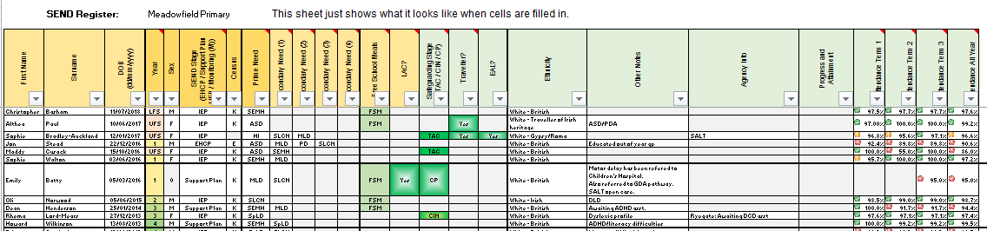

Part 2: Filling in the Register

The only tabs you need to enter data in are coloured purple. There’s three of them. All the other tabs are done for you.
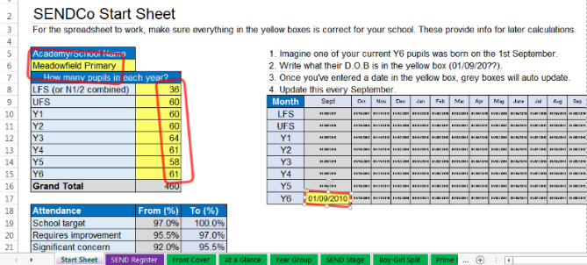

Step 1: Start Sheet
Fill (or correct) the 10 Yellow Boxes on the first tab.

Ignore anything that’s not yellow.

Check and update this every September.

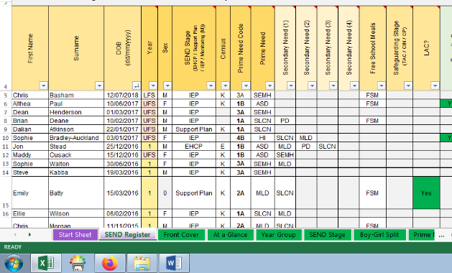

Step 2: SEND Register
Don’t do anything yet.

The column titles are frozen. That means that when you scroll down, you can still see the title for each column.

Take a look at the titles and take a look at the info that goes in the boxes.
It’s pre-filled in so that you can see what it looks like (but we’ll delete this existing info in a bit).

Step 3: Decide which optional columns you need
There are some columns that are useful to some, but not all, SENDCos. These have green coloured title boxes, for example Traveller?

If you have other systems that quickly tell you who is CP, CIN, LAC etc, there may be little value adding it here.

Before you start adding data, decide which columns you will/won’t find useful. Hide any you won’t be using. The rest of this page tells you how to hide the traveller column. The same steps can be used for any other optional column you want to hide.

Quick Tip: Hiding Cells
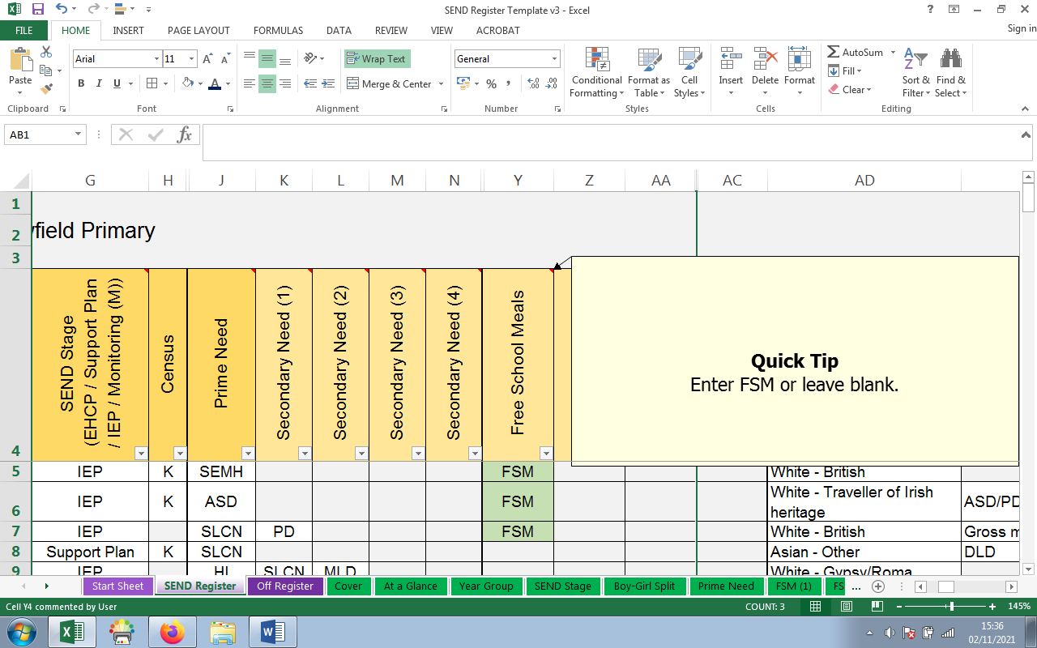
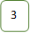
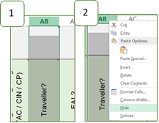

How to hide the traveller column
1. Right click on the letters at the top of the column.

2. Then choose Hide from the drop down menu.

3. You can see that it is still there because the column names go AA, AC, AD (and miss out AB). AB is still there, just hidden away out of sight.

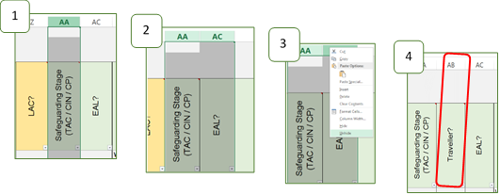
How to unhide the Traveller column?
1. Left click AA and keep your finger pressed down.

2. Drag the cursor across to AC so that both columns (AA and AC) are highlighted.

3. Right click AA or AC to get the drop down menu. Left click unhide.

4. The Traveller column will now have reappeared.

4. Fill it in
You can highlight all the cells with the example SEND Register in and press delete. Now copy and paste info from your current register.

Please note the tips below so that you don’t overwrite the colour coding.

Quick Tip: Avoid Overwriting Code (1)
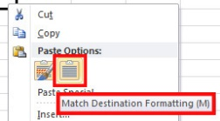
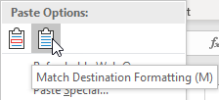
Right click where you want the data to go and choose Match Destination Formatting from the options given.

The icon looks like a clipboard with writing on.

Quick Tip: Avoid Overwriting Code (2)

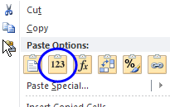
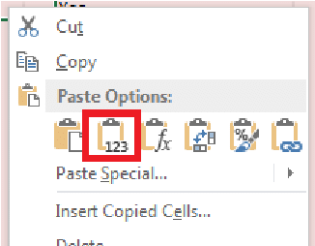
Copy & Pasting from Excel: Right click where you want the data to go and choose Values (V) from the options given.

The icon shows the numbers 1 2 3.

Ethnicity
This is a drop down box as it runs on DfE Ethnicity codes.

Drop down boxes aren’t perfect, but they’re much quicker than typing in ethnicity codes.

As White British appears to be the most common ethnicity in school, the easiest way to do this is to select White – British for your first child in the list. Then copy White – British in to all the boxes. Now, go back through the list and change the ethnicity for any child who has a different ethnicity.

Using paragraphs in Excel
When typing into cells, it is all one paragraph.
You can use space bar to get to a new line or a quicker way is to hold down the Alt key and press enter. This gives you a new line.


From: To:

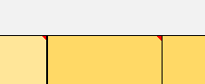
The little red triangles
Several column headings have red triangles in the top right corner. Move the cursor over these to get quick tips for that column.

Often, the box that pops up answers the question “What do I write in in this column?” For example:
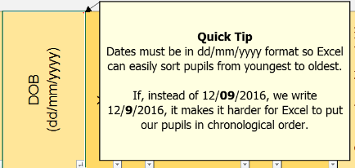
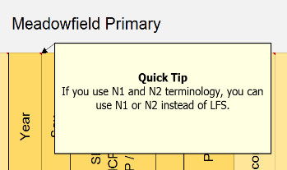
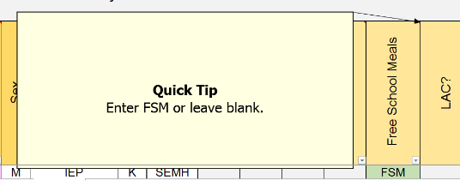

Move the cursor away to make the box disappear again.

Part 3: Trouble Shooting Tips
Audience: SENDCos, SEND Admin
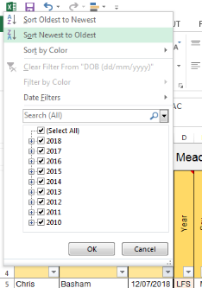

“I can’t sort by year group!”

Issue: When I try to sort by year group, I end up with LFS and UFS next to Y6.

Quick Fix: Sort by Date of birth instead.

Click on the arrow in the Date of Birth box and select to sort
newest to oldest to get the youngest pupils on top.

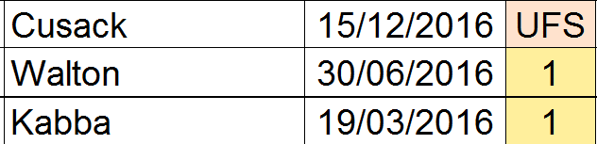
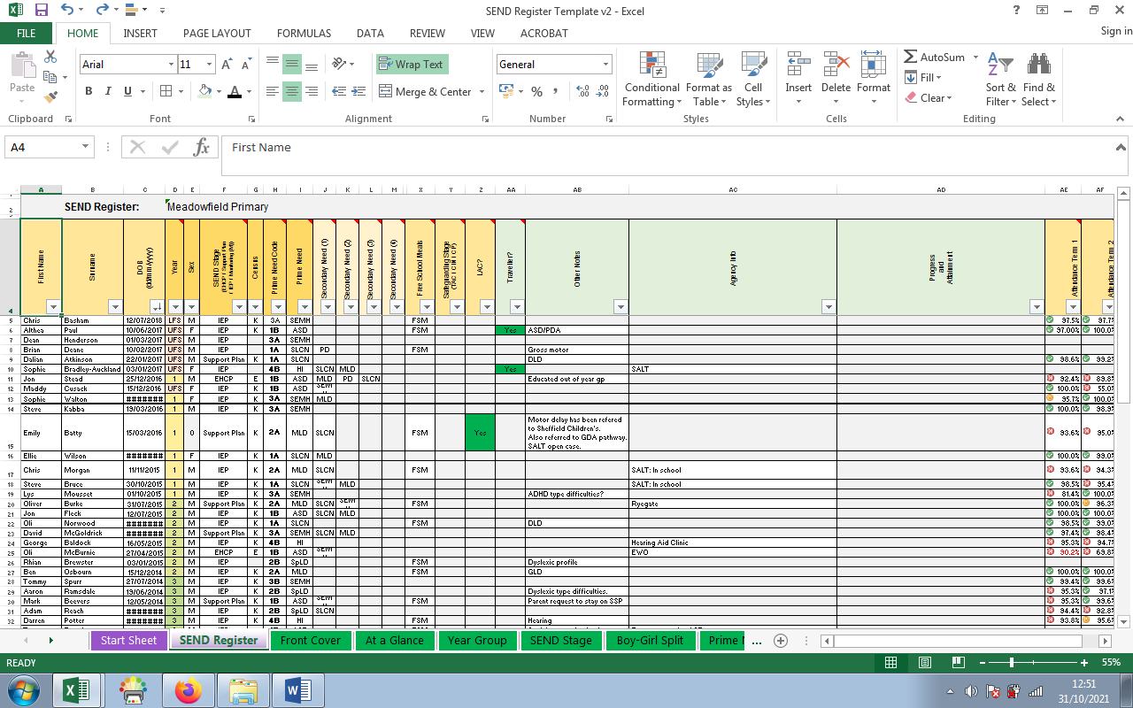

It’s replaced my info with ########

Issue: Excel shows hashtags (#) for some cells if you zoom out too much.

Quick Fix: Look at the bottom right of the screen. Click the cross to zoom in.

Alternatively, the text is wider than the column. So, just make the column wider.

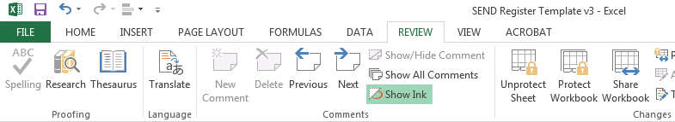
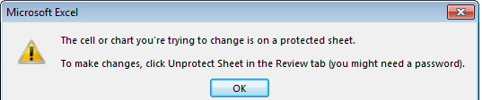
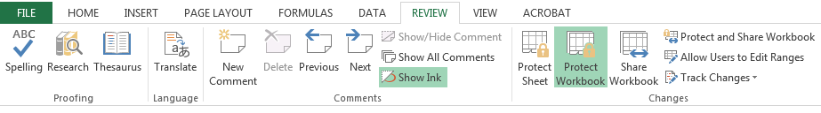
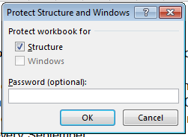

It won’t let me change cells. It says they’re protected

Issue: Much of the document is ‘Protected.’ You can still resize columns and rows but some analysis cells can’t be typed into. This prevents accidental deletion of formulas.

Quick Fix: You can unprotect any sheet you want. There is no password.

Click on Review.

Then click Unprotect Sheet.

You can now change anything and everything you want.

You can then reverse the steps to put the protective shield back in place. You don’t need to use a password to protect cells – it is just to keeps formulas in place and not for GDPR.

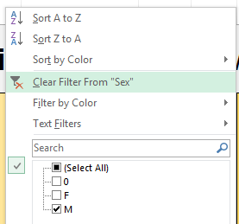
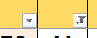

Some children are missing! (2)

Question: Some children are still missing! Aaaaaargh!

Quick fix: Make sure you’ve not left a filter on.

A filter is the small arrow that filters your SEND register to look for specific
categories. For example, you could use it to select only KS2 pupils.

You can see filters are on because the small arrow changes to a triangle with a funnel.

Right click on the funnel and click to Clear Filter:

Thick Black Lines

Issue: There are some thick black lines that appear on screen and when I print.

Quick Fix: Ignore them.

They are just there to help your eyes track across lots of cells.

If you keep them or get rid, no worries. They are not critical.

Some children are missing! (1)

Question: Some children are missing! Help!

Quick fix: Make sure you’ve scrolled up: Sometimes you think you are at the top of the spreadsheet when you aren’t. That’s because the title columns are frozen so they always appear on screen.

On the left hand side, the clue is the row numbers. Scroll up until the numbers show 4, 5, 6…

On the right hand side, the clue is the scroll bar is position. Scroll up to the top.

