

A Practical Guide to Inclusive Teaching and Support

Hall Cross Academy
SEND
Special Educational
Needs & Disabilities

v1.0

March 2026

Welcome
This booklet is rich in ideas to enhance your everyday practice.

It can be read cover to cover, but is also useful as a reference when you have a learner with a condition that you’ve not come across as often.

Learners are diverse. Two learners with the same condition can present in very different ways. Therefore, not every tip will be right for your learner(s) – that’s fine. This guide is to enhance your excellent judgement and not replace it!

Inclusion is everyone’s responsibility. Thanks for reading this booklet so that you can help every learner to achieve, belong and thrive.

Contents
Section 1: Inclusion for All
- What is QFT & SEND Support? 3
- Inclusive Presentation 4
Section 2: SEND Strategies for Staff
    - ADHD 7
    - Autism 9
    - Dyscalculia 10
    - Dyslexia 11
    - Dyspraxia 13
    - Hearing impairment 14
    - Moderate learning difficulties 17
    - Selective Mutism 19
    - Social, Emotional & Mental Health 20
    - Speech, Language & Communication 21
    - Stammering 22
    - Visual impairment 23
Section 3: Ofsted
- Considering evidence for inclusion 25
- Grading inclusion 28

Section 1: Inclusion for All
06
What are QFT and SEND Support?
Excellent quality first teaching (QFT) is the essential ingredient in the education of every learner.

The SEND Code of Practice (2015) defines high-quality teaching as:
“

Differentiated and personalised and will meet the individual needs of the majority...
”

The code makes it clear that,
“

Additional intervention and support cannot compensate for a lack of good quality teaching.
”

What does excellent QFT look like?

- High quality and ambitious curriculum
- High expectations and aspirations that are shared by everybody.
- Staff who have expert knowledge of what they are teaching.
- Systematic checking of learners’ understanding; identifying and addressing
misconceptions through clear, direct feedback.
- Adaptation of teaching as necessary.
- New learning that is built upon previous learning to enable learners to remember more.
- Learning environments that support learning.

SEND Support
SEND is:
- a learning difficulty or disability
- that needs additional or different provision to be made

The Department for Education publishes the SEND Code of Practice (2014). This guide covers learners aged 0 – 25.

The code outlines two distinct stages of support for those who have SEND:
- SEND support: For learners with mild or moderate SEND.
- Education, Health and Care Plan (EHCP): For learners with more complex needs. This is a legal document – think of it as a legal contract between a council, an education provider and the learner. It states what the provider needs to deliver and the outcomes that we need to work towards.

If a learner only has health care needs, this isn’t normally SEND support (e.g. checking insulin readings for Type 1 diabetes or having an emergency plan for a learner with a severe nut allergy). Any provision has to be related to the learner’s education to be SEND support (although there is sometimes an overlap such as supporting a learner who has significant learning difficulties to monitor their own insulin levels).

Even if a condition is not SEND (e.g. diabetes), the learner may still be covered by the Equality Act. Therefore, we may still need to make reasonable adjustments.

Inclusive Presentation
What is it?
It is the habit of making your writing as inclusive as possible from the start. This then means it’s easier for all learners to access.

This section gives tips to help you to make your presentation as inclusive as possible.

Alignment?
Generally, align left as this requires the eye to return to a predictable part of the page for each new line. There is that brief moment when we finish one line and go to find the next, if the next line is in a predictable place, then we read on more quickly.

Use centred text in small doses. It is great for titles and some sub-headings. It can also be useful for quotes to break up text:

“I love centred text, but only in small doses.”
Level 3 Apprentice, Business Administration

But, if your centred text is longer than 3 or 4 lines, it just slows down the reader. Why would we make our writing harder to read?

Avoid justifying text as the eye typically finds it easier to read words that are equally spaced along the line.

Whilst justified text is often found in books, this tends to be because of tradition and its visual appeal, rather than for readability.

Font Choices?
Use a dyslexia friendly font (e.g. Calibri, Arial, Comic Sans, Tahoma). These fonts aren’t too crowded and also don’t have serifs (the little decorative flicks on letters that make them more complicated).

Block Capitals?
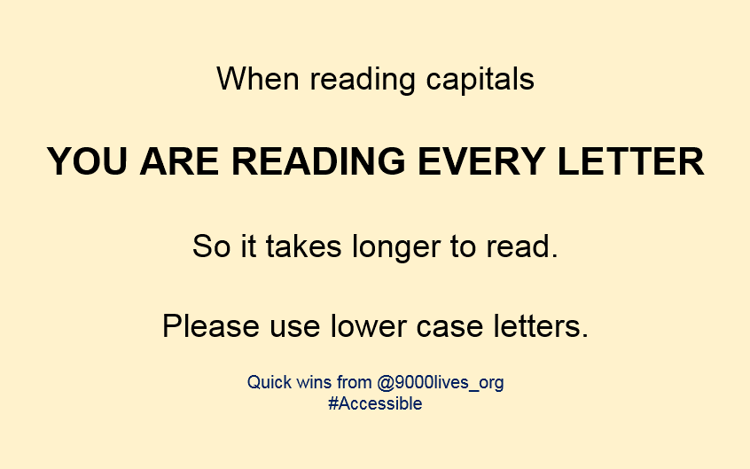
Avoid using block capitals:
Keep block capitals for acronyms or occasional emphasis, for example:
- The team have chosen to raise money for RSPCA.
- Rome was founded in 753 BC.

Colour Contrast
On presentations, reduce your use of black text on white backgrounds. Instead use slightly off white PowerPoint slide backgrounds (e.g. cream or pale blue).

Ensure a good contrast between text colour and backgrounds. That means dark font on light background or light font on dark background.

Good contrast  (and so easier to read) | Good contrast  (and so easier to read)
Bad contrast  (and so harder to read) | Bad contrast  (and so harder to read)

Avoid tone on tone (e.g. dark green on light green).

Lower contrast  (and so harder to read) | Lower contrast  (and so harder to read)
Lower contrast  (and so harder to read) | Lower contrast  (and so harder to read)

Height of Displays
Covering from floor to ceiling can make teaching spaces feel very cluttered. It can also create a distracting place for learners with attention difficulties. When displaying resources, choose quality over quantity.

Text on Pictures & Pictures on Text?





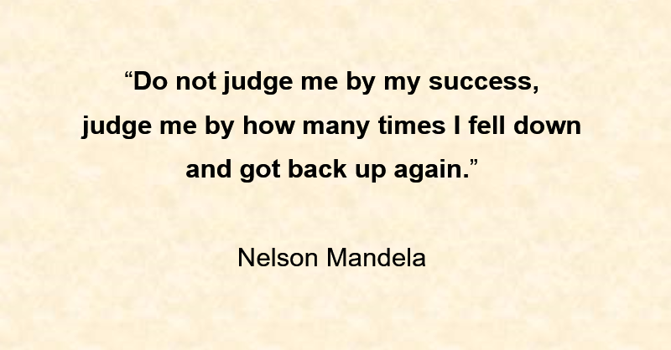

Avoid text over pictures, unless the background you are writing on is all a good contrast or is a fairly plain picture.

Section 2: SEND Strategies for Staff
(ordered A-Z)

Attention Deficit Hyperactivity Disorder (ADHD)
What is it?
ADHD is a medical diagnosis. Learners who have ADHD typically present as:
- Impulsive
- Inattentive and
- Overactive

You may hear some people talk about which type of ADHD they have. Some doctors specify that the ADHD is one of three sub-types:
- ADHD (inattentive type)
- ADHD (hyper-active compulsive type)
- ADHD (combined – i.e. a mix of both the above two types)

Recommendations for support
Keeping Focus | Promoting good conduct
Try to not have too many busy displays or distracting clutter in your learning space. | If concerned about missed deadlines, chat about what distracts them or gets in the way. Some people with ADHD spend far too long on their phones. If spending more than 2 hours a day on their phone this is a lot. Read https://adhdspecialist.com/post/adhd-and-phone-addiction and discuss ideas from the article with the learner.
Give clear expectations: “A draft needs to be produced by 19th; you will then need to share it with your presentation partner.” Present the request as though you assume they will complete it, not as a request to complete it. | Talk to the learner about the Forest app. This gamifies the action of not being distracted by your phone for periods you choose. Learners can connect
Use deadlines to help the learner complete a task in a specified period of time. It can be helpful to give updates on time remaining for tasks to ensure pace (e.g. “Reminder… two weeks left for project A”). This helps to avoid the learner’s work ‘drifting off’ from the pace needed. | If the learner is struggling to manage work tasks, chat to them about how they currently manage. Explore written or online methods for tracking tasks (e.g. via Outlook tasks, written to-do lists etc).
Chat to the learner about their workspace if they do any work (or apprentice assignments) from home. How distraction free is it? How productive a place to work is it? What are the distractions? Can we make any changes to help you to give you very best focus? | During lessons, ignore fiddling or twiddling. This can be an important way that the learner is helping themselves to focus. It can also be a self-soothing technique for those with anxiety as well.

ADHD (continued)
Promoting good conduct (cont.) | Mitigating inattention
Devise a signal to nudge the learner to refocus if they are off task (e.g. making eye contact and raising an eyebrow). Privately let them know what you’re doing and why so they can use it as a reminder to refocus). | Give instructions simply and clearly.
If the learner is engaging in impulsive behaviour that is harmful to them or others, raise the issue with the designated safeguarding lead or a safeguarding officer. | If demonstrating a short practical task, do it once whilst you explain the steps. Then repeat the task silently “I’m going to do it again without words. Watch the steps.”
If correcting issues, be specific about what you want the learner to do (rather than what you don’t). For example:  “N., I need you to tell me as soon as you realise a deadline is slipping.” instead of ‘N, don’t tell me after the event.” | For practical tasks, provide an example of the ‘finished product’ as a way of showing the outcome without needing lots of instructions.
If lateness is an issue, adjust your expectations. For example, instead of “See you all back at 1pm please.” Say “Aim for 12.55 back here so you’re ready for a 1pm start.” | For new tasks that have multiple steps: Display the instructions on the board so that learners can check back on the steps needed as they go along.
Relationships and trust are really important. To build these, remember to give plenty of positive feedback. | In 1:1 meetings, ask the learner to summarise the key action points or learning from the session.
Ask the learner – “OK. So, I’m worried that xy has gone wrong… How do you think it needs fixing?” | Avoid asking “Do you know what you’ve got to do?” (which often gets the answer ‘Yes’ even when the learner has not understood the task). Instead say “Tell me what you’ve got to do.”
In down time, chat about whether they do any sport (physical activity is considered very beneficial for adults who have ADHD and can reduce the effect of ADHD on the person).

Autistic Spectrum Disorder (ASD)
What is it?
It’s a lifelong condition that affects four areas:

- Communication: Language development is disordered, which may include unusual speech intonation (e.g. speaking in a US accent), poor understanding of body language and facial expression or a spikey profile (e.g. a Y2 has vocab about the channel tunnel which is way above is age, but generally has very limited vocab about other topics).
- Social interaction: Can include difficulties making friends, keeping friends, sharing play, holding two-way conversations.
- Imaginative thought, inflexible or over-literal thought processes: This can include obsessional behaviours or difficulty dealing with change.

Enjoying excellence every day.
- Sensory differences: Can be over or under sensitive to sensory input (touch, taste, proprioception etc).

Recommendations for support
Teaching approaches | Communicating with the autistic learner
If a learner becomes anxious, allow them to remove themselves to an agreed area. | Use the learner's name before asking a question or giving an instruction.
Be open to explaining social rules if learners make social slip-ups. | Use short simple instructions. Give one at a time and check for understanding. Repeat instructions in the same words rather than different ones. Ask learners to repeat them back to you.
If demonstrating a short practical task, do it once whilst you explain the steps. Then repeat the task silently “I’m going to do it again without words. Watch the steps.” | It’s worth explaining any metaphors and idioms might not make sense ‘head’s on the block’, ‘down the line’, ‘as fit as a butcher’s dog’. “If you’ve not heard the expression ‘down the line’ before, it just means you’ll do it later.
For practical tasks, provide an example of the ‘finished product’ as a way of showing the outcome without needing lots of instructions. | Give clear written instructions for projects or presentations - ideally in numbered steps. This helps the learner to remember what they need to do (and by when).
For new tasks that have multiple steps: Display the instructions on the board so that learners can check back on the steps needed as they go along. | If a learner goes off on a tangent, direct conversation back to the topic in hand; ‘We’ve drifted off a little, let’s get back to…’
Ensure the learner is recording deadlines into their calendar (and setting up reminders, e.g. 1 week before deadline, to stay on track). | In 1:1 meetings, ask the learner to summarise the key action points or learning from the session.
If you can, let the learner know of any changes of routine in advance (e.g. different tutor).

Dyscalculia
What is it?
Dyscalculia is a specific learning difficulty with maths skills. It may be a difficulty with counting and calculating, understanding abstract maths concepts or working with numbers and symbols.

Recommendations for support
Teaching Approaches | Encourage learner to say what they’re doing and why.
Establish a routine of ‘Estimate – Calculate – Check’. | Word Problems
If the learner is destined for an office based career, Chat about their skills with MS excel. Chat about whether they would benefit from accessing any of the many online courses to improve Excel skills. | Link maths to relevant and practical contexts, for example, shopping or eating out or booking coaches for football team’s fans to travel to Wembley.
Use a ‘scaffolding’ approach – avoid rushing the learner through a task. Break it down into steps. Provide time for recap & consolidation at each stage and revisit the basic skills often. | Take time to explain / recap on maths vocabulary. Check for understanding.
Allow learners as much thinking time as they need to complete a calculation. If they need more time say, for example: “Use your whiteboard to work out (sum), I’ll come back to you in a minute. | Ask lots of questions, rephrasing your sentences and varying your vocabulary.
Do not assume silence means that the learner is ‘stuck’ they may well be calculating but just taking a long time to do it. Wait. Let them tell you if they are stuck. | Minimise the amount of information that learners have to hold in their mind at any one time. For example, if they are performing division, they should write down every step including carrying numbers.
Provide opportunities to over-learn maths concepts and rules, for example via spaced learning, games, tables tests. | When solving harder problems, they should always have paper handy to jot down the steps in their calculations. This will help prevent them from losing their place and forgetting what they are doing.

Dyslexia
What is it?
Dyslexia is a specific learning difficulty that affects the ability to read and spell. Dyslexia can also cause difficulties with short-term memory, processing instructions and being organised. We often talk about a specific learning difficulty (SpLD) in literacy as a diagnosis are generally only available if individuals are willing to pay for an expensive assessment.
Fortunately, strategies can be put in place without a diagnosis.

Dyslexia affects people across all levels of ability and tends to affect boys more than girls. It often runs in families and is believed to have a genetic cause. British Dyslexia Association say that it affects up to one in ten people.

Recommendations for support
Presentation of Information | Promote Self-Help Skills
Use sans-serif fonts. For example:  - Arial  - Calibri  - Century Gothic  - Tahoma | Promote the use of speech to text (toggle on/off on Word by pressing the Windows and H keys).
Use 1.2x-line spacing. | Promote the use of read aloud for longer texts (toggle on/off on Word by pressing the Alt, Ctrl and space).
Check with the learner if they’ve previously had resources on pale coloured paper and ask whether they think it made any difference. If so, try to provide printed resources on their preferred colour. | Encourage learners to ‘line track’ with a ruler (for example, if you are reading out some handouts, they move the ruler down the lines as you read and it helps them to focus).
Avoid writing unnecessarily long sentences that require more short-term memory to understand:  “You should always clean as you go as it keeps the kitchen safe and it shows good hygiene practice and inspectors will be looking for that.”  Becomes  Clean as you go. This keeps the kitchen safe and hygienic. Inspectors will look for both safety and hygiene. | Give clear written instructions for projects or presentations - ideally in numbered steps. This helps the learner to remember what they need to do (and by when).
Avoid tautology (including redundant words):  X: You must plan ahead in advance…  X: The basic fundamentals of food safety  X: Our overarching policy is… | Explore the use of checklists, reminder notes and visual timetables to help the learner to self-organise.

Dyslexia (Continued)
Teaching Approaches | Use mnemonics (see below)
Focus feedback on ideas and content rather than on time spent, neatness, spelling etc. | If demonstrating a short practical task, do it once whilst you explain the steps. Then repeat the task silently “I’m going to do it again without words. Watch the steps.”
Ask the learner to repeat back instructions to you in their own words. | For practical tasks, provide an example of the ‘finished product’ as a way of giving instructions without relying on verbal information.
Discuss extra time for tests.  Discuss extra time for projects. Help the learner to weigh up options “We’ve still got an end date of dd/mm/yy, but let’s think about whether there is any small scope or whether that’s going to make you feel like you’re falling behind…” | Use AI (e.g. Chat GPT) to draft ‘What a good one looks like.’ Check and annotate it. Provide it to learners. For example:  Para 1 = Setting scene (workplace, staff)  Para 2 = The problem we faced (menu too broad)  Para 3 = How I contributed (suggested removing three most time consuming main meals)  This is so they spend less bandwidth thinking about the structure of the work and can crack on.
Write sequences of instructions in numbered steps. | Other
Minimise copying from a board or PowerPoints. Provide pre-printed information instead. | Respond empathetically if a learner forgets things, for example “I understand. So, what’s the plan now to get your project to me.”

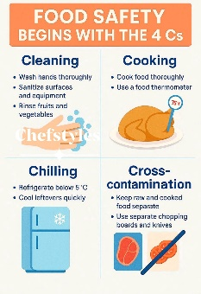
Use mnemonics to help learners remember key information
Mnemonics are patterns of letters or ideas that help us remember things. For example:
1. The Four Cs of food safety: Cleaning, Cooking, Cross Contamination and Chilling.
2. PASS - Remember PASS for fire extinguishers.
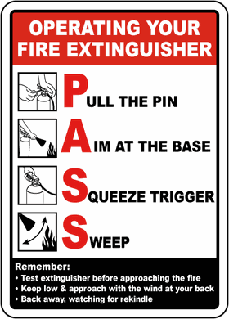
P – Pull the pin
A – Aim at the base of the fire
S – Squeeze the handle
S – Sweep side to side

Display key mnemonics in your learning space.

Encourage more reading
Reading underpins so much of our lives. A low reading age is not going to fix itself. Encourage the learner to look for ways to increase their time enjoying reading. Chat about what this might be. For example, could it be taking over bedtime story for their children, reading DC or Marvel comics, having subtitles on when watching TV?

Dyslexia is a barrier, but let’s think of the brain as a muscle – one that we can work out and improve.

Dyspraxia
What is it?
Dyspraxia is a specific learning difficulty. Learners with dyspraxia have problems with motor coordination and may:
- appear clumsy when moving around or completing practical tasks
- find writing difficult
- have pronunciation difficulties caused by problems in controlling the movements of the mouth.

What is DCD?
DCD is another name for dyspraxia and is short for Developmental Co-ordination Disorder.

Health workers, such as Occupational Therapists, tend to use the term DCD, so it’s useful to know that it means the same as dyspraxia.

The condition can also affect planning and organisation. DCD is estimated to affect up to 5% of the population. It affects four times as many boys as girls.

Recommendations for support
Seating | Teaching Approaches
Encourage the learner to sit near the front of the room and try to minimise visual distractions. | Read above advice for dyslexia as many of those will help a dyspraxic learner’s organisation and memory.
Communicating with the learner | Try to avoid disturbing the learner when they are in the middle of a task.
Get the attention of the learner before giving instructions. | In down time, chat about whether they do any sport (exercise is generally considered beneficial for adults who have DCD).
Give simple instructions… The shorter, the better. For example: “Get your materials. Set up your workstation and then come back.” | If they’ve had Occupational Therapy, make sure you’ve read any reports (especially from the past 2-3 years) as these often have great advice.
If you need to repeat instructions, don’t make it a big deal, for example if asked ‘What did you say?”:  “No prob Jack… Grab your materials, set up your workstation and then back here. Thanks.” | Ask about the dyspraxia assessment they had. Did they get a report: “If so, please can I have a read?” These sometimes have cognitive assessments that help us better understand the learner’s strengths and weaknesses.

Hearing Impairment (HI)
What is it?
A hearing impairment is a hearing loss that prevents a person from totally receiving sounds through the ear. If the loss is mild, the person has difficulty hearing faint or distant speech. When the hearing loss is profound, the person may not be able to distinguish any sound.

- Mild HI - Learners cannot hear soft noises. They may have trouble following conversations when the room is noisy.
- Moderate HI - Learners cannot hear soft or moderately loud noises. They may have trouble hearing unless they use a hearing aid.
- Severe HI - Learners are unable to hear most noises. They may rely on lip-reading and/or British Sign Language (BSL), even with if they have a hearing aid.
- Profound HI - Learners may only hear very loud noises or none at all. They may rely on lip-reading and/or British Sign Language.

An audiologist can measure a person’s hearing loss. Their measurements, and the audiology graph that they often provide, tell us how loud sounds need to be for a person to hear. There are widely used ‘bandings’ that were devised by the British Society of Audiologists.
Level of Loss | Decibel Hearing Level
Mild | 21-40 dB
Moderate | 41-70 dB
Severe | 71-95 dB
Profound | >95 dB
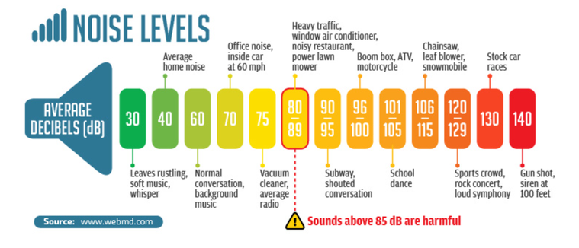

Unilateral or bilateral?
- Unilateral hearing loss means the learner has hearing loss in one ear.
- Bilateral hearing loss means both ears are affected.

What do sensorineural and conductive mean?
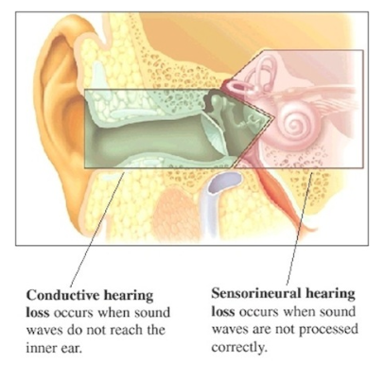
They are both words that tell us what part of the ear is causing the hearing loss.
- Conductive: If it’s outer ear or middle ear that’s affected, it’s a conductive hearing loss.
- Sensorineural: If it’s the inner ear or the brain that’s affected, that’s a sensorineural hearing loss.
- Mixed: If the person has both conductive and sensorineural hearing loss, then it’s called a mixed hearing loss.

Hearing Impairment (Continued)
Recommendations for support
Seating | Expert advice
Seat them at the front. If they have a ‘better ear’, seat them with their best ear facing where you most often deliver from. | For those who’ve recently left school or college, ask the learner for any reports from audiologists or Qualified Teacher of the Deaf (from the past 2-3 years). These often have great advice that is tailored to the individual’s hearing loss.
It might sound simple but, after allocating a place, ask the learner:  “How well are you finding hearing?”  “Is it better than where you were?  “Where there any bits of the session that you found hard to hear?” | For those who are longer since leaving school or college, ask them for any written letters or reports from hearing tests or ENT clinic (Ear, nose, throat) or audiology clinics.
Teaching approaches | Communicating with the Learner
Minimise background noise. | Make sure instructions for tasks are written (e.g. write on a whiteboard, send via email).
Use the learner’s name before asking a direct question or giving a direct instruction. | Agree on a discreet signal that the learners can use to show you when they have not heard or understood.
Speak clearly, naturally and at a normal rate – shouting or exaggerated ‘mouthing’ distorts normal lip patterns. | Paraphrase the contributions of others back to the class, for example “So, you’re finding the portfolio tricky to get started.”
When speaking, extend natural pauses to provide the learner with a short break as lip-reading your normal rate of speech can take up a lot of energy and can be tiring for the learner. | When a fellow learner asks a question, repeat the question before answering it:  Learner: Are we expected to make a PowerPoint for our presentation?  Tutor: You’re asking about having to use PowerPoint for presentations. Yes – you can, but if you want to do it in other ways, that’s acceptable too.
Give straightforward instructions. | Other
Try to minimise walking around the class whilst speaking to your whole group. | If covering technical subjects, share key vocab for topics with definitions.  You can use AI, to quickly generate the definitions (as long as you double check that the definitions are appropriate). See example on next page.
If repeating instructions, use the same wording second time. Only if these are not then understood, substitute different words. | Support oral information with diagrams, pictures or real objects.
When in conversation, if the learner mishears something, patiently repeat it - a frustration reported by many who have HI, is being told “It doesn’t matter” when they ask for clarification. | Be aware of the fatigue and frustration a learner may experience because of the amount of effort they have to put in to listening.
Online Meetings
When meeting over Teams, ask the learner if they would like Live Captions turned on. This provides subtitles in real time. | If you are finding that they are not accurately transcribing your words, then try to speak more like a newsreader does (they articulate each word and make sure that words don’t blend into each other).
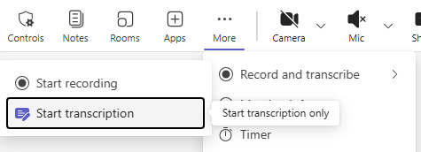  Live captions can be toggled on/off under ‘Record and transcribe. If recording, it will also transcribe. Or you can Start transcriptions which gives the subtitles without recording the meeting. | Don’t worry if live captions aren’t perfect at first – as you practice, you get better at speaking in a way that is accurately translated.
Take extra care when using technical terms (louver, HMRC) or acronyms (e.g. AQA). Make sure you don’t gabble these words try speaking ever-so-slightly slower. | For less severe hearing loss, closed captions support their hearing (i.e. if they miss words, they can see them on screen, so the occasional wrongly transcribed word is not a massive problem). Nevertheless, try to become really polished at your speech style.

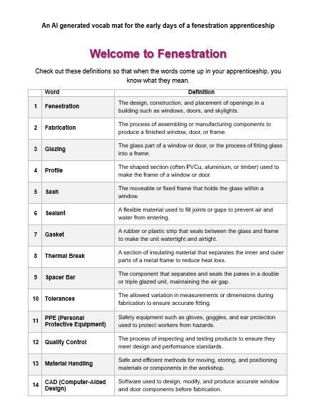

Moderate Learning Difficulties
What is it?
Learners with moderate learning difficulties (MLD) have difficulties with all areas of learning.

A general rule of thumb is that this group are in the lowest 2% of all learners in their age group. Many learners with MLD also experience low levels of self-esteem and motivation. Some may become resentful and reluctant to attempt new work as they perceive that they are likely to fail even before they start. In previous settings, some may have been over-reliant on learning support staff to help them with tasks. Therefore, promoting their independence-skills is important.

Recommendations for support
Teaching Approaches | Minimise copying from a board or PowerPoints. Provide pre-printed information instead.
Break down tasks into small, clear steps. If possible, number these in a list. | If demonstrating a short practical task, do it once whilst you explain the steps. Then repeat the task silently “I’m going to do it again without words. Watch the steps.”
Ensure the learner is recording deadlines into their calendar (and setting up reminders, e.g. 1 week before deadline, to stay on track). | For practical tasks, provide an example of the ‘finished product’ as a way of giving instructions without relying on verbal information.
Use mnemonics (see below) | Communicating with the MLD learner
Discuss extra time for tests.  Discuss extra time for projects. Help the learner to weigh up options “We’ve still got an end date of dd/mm/yy, but let’s think about whether there is any small scope or whether that’s going to make you feel like you’re falling behind…” | Give simple instructions… The shorter, the better. For example: “Get your materials. Set up your workstation and then come back.”
Use AI (e.g. Chat GPT) to draft ‘What a good one looks like.’ Check and annotate it. Provide it to learners. For example:  Para 1 = Setting scene (workplace, staff)  Para 2 = The problem we faced (menu too broad)  Para 3 = How I contributed (suggested removing three most time consuming main meals)  This is so they spend less bandwidth thinking about the structure of the work and can crack on. | If you need to repeat instructions, don’t make it a big deal, for example if asked ‘What did you say?”:  “No prob Jack… Grab your materials, set up your workstation and then back here. Thanks.”
Try to avoid disturbing the learner when they are in the middle of a task. | Ask learners to repeat instructions in order to clarify understanding.
Explore the use of speech to text to complete assignments. Use the IT Tips for Apprentices booklet to guide how to do this on MS Word. | Praise every effort and successful achievement of new skills.

Use mnemonics to help learners remember key information
Mnemonics are patterns of letters or ideas that help us remember things. For example:
1. The Four Cs of food safety: Cleaning, Cooking, Cross Contamination and Chilling.
2. PASS - Remember PASS for fire extinguishers.
P – Pull the pin
A – Aim at the base of the fire
S – Squeeze the handle
S – Sweep side to side

Display key mnemonics in your learning space.

Encourage more reading
Reading underpins so much of our lives. A low reading age is not going to fix itself. Encourage the learner to look for ways to increase their time enjoying reading. Chat about what this might be. For example, could it be taking over bedtime story for their children, reading DC or Marvel comics, having subtitles on when watching TV?

Selective Mutism
What is it?
Selective mutism is a severe anxiety disorder where a person is:
- Not able to speak (or ‘mute’) in certain situations, for example, at college or the park).
- Able to speak where they feel relaxed, for example, at home.

Selective mutism is more common in children than adults. It usually starts during childhood but, left untreated, can persist into adulthood. It is more common in females and those who are learning a second language.

A learner with selective mutism does not refuse or choose not to speak; they are unable to speak. The expectation to talk triggers a freeze response with feelings of panic, such that talking is not possible.

The term selective mutism replaces the outdated term elective mutism.

Recommendations for support
 | Teaching Approaches
1 | Do not try to insist that the learner speaks.
2 | Do seat the learner to the side in the classroom… not front and centre where everyone is looking at them.
3 | Do let the learner know that you will help them, but not force them to talk.
4 | Do not say to people “They don’t talk.”
5 | Do include the learner in teams and group activities, regardless of verbal communication.
6 | Do accept the learner communicating in other ways, for example nodding their head for yes, or using written communication.
7 | Do not overly respond if the learner does speak. Act as if it were normal and continue with your activity.

Want more info?
Check out the NHS intro to selective mutism here: www.nhs.uk/mental-health/conditions/selective-mutism (or find this info by Googling: NHS Selective Mutism).

2022- 2023

Social, Emotional and Mental Health
What is it?
It’s a wide range of social and emotional difficulties, which include more passive behaviours (e.g. becoming withdrawn or isolated) as well as more active behaviours (e.g. challenging, disruptive or disturbing behaviour).

The learner’s behaviours may reflect what’s going on in their mind, such as anxiety, ADHD or attachment difficulties.

Some learners have deep-rooted emotional difficulties that manifest themselves in unusual quietness, rather than disruptive behaviour. It’s important to notice them too.

This page focuses on those with challenging behaviour.

Recommendations for support

Bond with the learner | Preventing and dealing with issues
Welcome the learner personally at the start of each day – “Hello Billy, it’s good to see you…” | Avoid being caught up in confrontation about trivial issues. Give a short instruction with “thank you” at the end and then walk away. If needed, return a few minutes later and repeat the instruction.
Praise and reward all attempts at a task and place emphasis on effort even if unsuccessful (e.g. “Not perfect but a good first effort at it”). | If a learner starts to raise their voice, keep your voice quiet and calm. Save your shouting for emergencies.
‘Catch the learner being good’ and comment on what they’re doing well. | If issuing sanctions, explain to the learner what you are doing and why.
Take time to tell the learner their success matters to you “There is so much to like about you, and I want you to succeed.” | If something went wrong, debrief when the learner is ready. Ask questions such as:  - How were you feeling at that point?  - What could have gone better?  - What have you learnt from it?  How can it be prevented from happening again?
In downtime, get to know them a little better. What makes them tick. What do they like doing beyond their course? | Avoid using body language relating to aggressive control – pointing downwards, forcing constant eye contact, shouting etc.
Be discreet when challenging minor unacceptable behaviour. For example, make eye contact, point to your eyes and say “Safety goggles”, give them time to replace the PPE, then give a thumbs up before walking away. | Challenge unacceptable behaviour by using the language of agreement and fairness for all – “The agreement we have in this class is that there’ll be no swearing, so that each of us has a chance to work in an environment that’s appropriate.”

Speech, Language & Communication Needs (SLCN)
Speech difficulties are when a learner:
- Is unable to produce speech sounds correctly or fluently, or
- has problems with his or her voice
- has a stammer

Receptive and Expressive language difficulties
- Receptive language difficulties: When a learner has trouble understanding others.
- Expressive language difficulties: When a learner has difficulty expressing themselves in words.

In short, both speech and language difficulties come under the umbrella of SLCN.
- Speech difficulty is struggling to physically / mentally get the words out of your mouth.
- Language difficulty is struggling to comprehend words or know the words to say.

Speech and language do often appear together.

Recommendations for support
Teaching Approaches | Communicating
Read any recent Speech and Language Therapy reports (from the past 2 years). These often contain good explanations of the learner’s difficulties. These may also have practical ideas that can be built into any support plans. | Adults can feel embarrassed if corrected publicly. Instead, model back naturally:  Learner: “I done the form.”  Tutor: “Yes, you did the form, thanks. Let’s take a look at the next one.”
Show examples of completed work: What does a good one look like?  - A well-presented response to a customer complaint.  - A completed stock take sheet. | Allow time to process information.
Encourage planning before speaking. For example, in Business Admin, learners can use a 4-point plan for their presentation: What’s the issue? What’s been done? What difference did it make? What’s next? | Don’t assume silence means that they haven’t understood. They sometimes just take longer than you’d expect to think through their answer so give them time.
Demonstrate how to turn on Read Aloud. Ask learner to trial this so that they can hear longer texts at the same time they’re reading it. Ask the apprentice to consider if that helps them improve their understanding of the subject-related text. | Teach communication self-advocacy: Help learners practise saying “Could you repeat that please?” or “I’d find it easier if I can see that written down.”  Use low-stakes role play so they can rehearse this safely.

Stammering
Stammering is introduced in the previous pages on speech, language & communication needs.

Typically, those who stammer respond well to a less hurried lifestyle and flourish in a routine and structured environment. So having a well organised and predictable approach to delivery will help (e.g. setting out deadlines in advance – or even providing all/most deadlines at the outset of the course).

Recommendations for speaking with those who stammer:
Try to | Try to Avoid
Slow down your own rate of talking. | Firing too many questions, too quickly.
Reduce the number of questions that you ask and make sure you give the learner time to answer. | Hurrying them or imposing a time pressure to their speech.
If you ask questions, try to lean towards closed questions, as these require a shorter answer. | Asking a second question when they are struggling to get the words out to answer your question.
Allow time for the learner to finish what they have to say. | Finishing their sentences.
Keep easy eye-contact when you are talking to the learner, especially when they stammer. | Asking them to start again.
Listen carefully to the learner, place emphasis on what they are saying and not how they are saying it. | Interrupting.
Pause for a few seconds before responding to the learner as this encourages them to take their time before talking. | Making light of the situation.
Comment on the things they do well as this helps to build their confidence.

Want more info?
To find out what it’s like to have a stammer, check out stamma.org/about-stammering/if-you-dont-stammer-read.


Visual Impairment (VI)

Enjoying excellence every day.

Enjoying excellence every day.

Enjoying excellence every day.

Enjoying excellence every day.

Enjoying excellence every day.

Enjoying excellence every day.

Enjoying excellence every day.
What is it?
Visual impairment means having reduced sight. It can affect how far a person can see, but can also affect near vision. Also, a person’s field of vision can be affected – that means how much the person can see around the edge of their vision whilst looking ahead.
- Visually impaired – reduced sight, that can’t be fixed by glasses or contact lenses.
- Blind – having no sight at all, or so little that it is not far from having no sight at all.

So people who wear glasses or contacts aren’t VI?
Yes and No.
- If there is reduced sight and glasses/contacts correct the vision, then it is not VI.
- If there is reduced sight and glasses/contacts don’t work at all, then it is VI.
- If there is reduced sight and glasses/contacts do help, but the person still has reduced sight, then it is VI. This would be the case if a person had severely reduced sight but wore glasses that meant their sight was moderately reduced.

How is VI measured?
It’s called the Snellen Scale and it usually involves the number 6… Imagine you are sitting 6 metres away from an object. How far away does that object look? For people with standard vision it looks like it is 6 metres away. For people with visual impairment, it might look the equivalent of 24 metres away for a person with standard vision. This would be scored 6 /24.


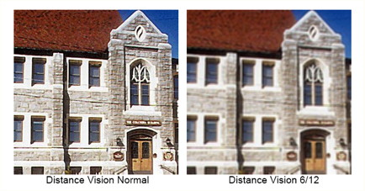

Here’s what it would look like being 6m away from a building with different levels of VI:

Eye tests are free for 16, 17 and 18 year olds in full time education. They are also free for those with diabetes or glaucoma as well as those on a range of benefits. The NHS provide a full list of eligible people.


What does field loss look like?
It depends on the severity, but here’s an example of a learner’s vision with field loss. Notice the reduced clarity around the sides of this learner’s vision.

Visual Impairment (Continued)

Enjoying excellence every day.

Enjoying excellence every day.

Enjoying excellence every day.

Enjoying excellence every day.

Enjoying excellence every day.

Enjoying excellence every day.

Enjoying excellence every day.
Recommendations for support
Seating | Use dark pens on whiteboards (black, blue, purple).
Seat learners at the front, this helps them to use their hearing to follow along. | Try to have a quiet learning environment - learners with VI rely heavily on their hearing to learn.
Sit the learner with VI next to patient peers as the learner will need to ask questions from time to time. | Provide commentary to replace/supplement information from pictures, questions, facial expressions – “This is a model of a skull, at the front you can see the jaw bone…” and so on.
Presentation of Information | Teaching Approaches
Try to make PowerPoint with a dark background and light writing. The greater the contrast the better. Use a large, plain font. Avoid cluttered or busy slides – learners with VI benefit from a logical top-to-bottom and left-to-right display. | Time checks can be helpful (e.g. “20 minutes left”) – VI learners will often struggle to keep track of time without a specialist watch.
  Check if they need text at a different size (N36 means size 36 on MS word). For context, this booklet mainly uses size 11 and 12 font. | Allow extra time to complete tasks and be aware of the fatigue the learner may experience because of the amount of effort they have to put in.
Use non-glossy paper and clear font colours. On white paper, clear font colours are:  - Black  - Dark blues, greys and purples  Very dark greens, reds and browns | Ask the learner if they have any previous reports or assessments that give information about their visual impairment (for example, recent school leavers may have reports from a Qualified Teacher of Visual Impaired and these often have great advice. Often eye conditions do not deteriorate – that means that even if a report is 2 or 3 years old, it could still have useful information on teaching approaches.
Check out the section on inclusive presentation at the start of this guide.
Communicating with the VI Learner | Organisation
Say the learner’s name before asking a direct question or giving a direct instruction. | Give written instructions for assignments.

Section 3: Ofsted’s approach to Inclusion

Enjoying excellence every day.

Enjoying excellence every day.

Enjoying excellence every day.

2022- 2023

Inclusion (whole-provider level)

This evaluation area considers how leaders and staff identify and support the needs of learners and apprentices. These include:
- disadvantaged learners and apprentices who face challenges that hinder their educational progress; the term ‘disadvantaged’ refers to learners and apprentices who have been eligible for free school meals in the past 6 years and those from low-income families.
- learners and apprentices with SEND and learners who receive high needs funding; this includes learners and apprentices who receive additional support with their learning and those with an education, health and care (EHC) plan.
- learners and apprentices who are known (or previously known) to social care, such as those who are under the age of 18 and in care, and care leavers.
- learners and apprentices who are known (or previously known) to youth-justice services.
- learners and apprentices who face other barriers to their learning and/or well-being, including those who were previously not in employment, education or training (NEET).
Inspectors focus on the factors that professional standards, non-statutory guidance, research and inspection evidence indicate contribute most strongly to inclusion.
These factors are:
- setting high expectations for all learners and apprentices, in particular those who are disadvantaged, those with SEND or high needs, those who are known (or previously known) to social care, and those who may face other barriers to their learning and/or well-being, including those without level 2 English and/or mathematics.
- establishing a culture in which early and accurate assessment of learners’ and apprentices’ needs is prioritised.
- reducing barriers to learners’ and apprentices’ education, training and/or well-being to support their development, involving specialists where appropriate.
- working closely and effectively with learners and apprentices, parents (where appropriate), professionals and staff, and ensuring that learners’ and apprentices’ views and aspirations are included in decision-making about the support they receive.

Gathering evidence about inclusion

Identifying and assessing needs, and reducing barriers
In gathering evidence about identifying, assessing and reducing barriers, inspectors evaluate the extent to which leaders:
- have established a culture in which staff understand the range of barriers that learners and apprentices may face to their learning and/or well-being, including those specific to their community and context; they work quickly and accurately to identify learners and apprentices who are facing those barriers.
- make sure learners and apprentices receive effective support, consult with external specialists and implement their advice as necessary, and ensure that appropriate reasonable adjustments are made in accordance with the Equality Act 2010 and the SEND code of Practice.
- ensure that any accessibility planning meets the requirements of the Equality Act 2010, and is implemented effectively and reviewed regularly.
- make sure that the use of any alternative settings is suitable, safe and in learners’/apprentices’ best interests.

Supporting disadvantaged learners and apprentices
In gathering evidence about supporting disadvantaged learners and apprentices, inspectors evaluate the extent to which leaders:
- have a secure understanding of their disadvantaged learners’ and apprentices’ needs and use appropriate evidence to inform their approaches to addressing these.
- make sure that the delivery of their inclusion strategy, and any associated strategies and policies, is sustained and monitored effectively, including through training and support for staff.
- continually monitor the impact of their approaches, including their inclusion strategy and any associated strategies and policies, and make helpful and proactive adaptations as appropriate
- ensure that their approaches, including those to their inclusion strategy and any associated strategies and policies, have a positive impact on learners’ and apprentices’ achievement and/or well-being

Supporting learners and apprentices with SEND and high needs
In gathering evidence about supporting learners and apprentices with SEND, including those who receive high needs funding, inspectors evaluate the extent to which leaders:
- have an appropriately experienced leader who ensures that the provider’s support is effective in making a positive difference for learners and apprentices with SEND and those who receive high needs funding, and draws on specialists where necessary.
- identify learners’ and apprentices’ emerging and changing needs quickly and accurately.
- ensure that the ‘graduated approach’ (a continuous cycle of ‘assess, plan, do and review’ that helps to ensure that learners and apprentices receive an appropriate level of support) is used in a way that is effective in meeting learners’ and apprentices’ needs, and that staff receive suitable training and support to implement it successfully.
- ensure that their work improves the progress and achievement of learners and apprentices with SEND, and that they do not lower their expectations of them.
- are committed to and understand their role in the local area partnership’s strategy to improve the experiences of, and outcomes for, learners and apprentices with SEND and those who receive high needs funding; where appropriate, leaders ensure that the local partnership’s strategies have a positive impact on learners and apprentices at the provider.
- meet the needs of learners and apprentices with SEND, making reasonable adjustments to the environment and the provider’s wider offer, which help to ensure that these learners and apprentices access education and training.

Supporting learners and apprentices who face barriers to their learning and/or well-being
In gathering evidence about supporting learners and apprentices who are facing barriers to their learning, progression, achievement and/or well-being, inspectors evaluate the extent to which leaders:
- are alert to learners’ and apprentices’ emerging and changing needs and can quickly identify those who are at risk of not attending or engaging in their learning programmes as result of a change in their circumstances and/or those whose well-being is deteriorating.
- sensitively approach learners and apprentices to offer support to ensure that they can continue with their learning programme(s) and maintain their well-being.
- are knowledgeable and well informed about issues in their communities that might affect learners’ and apprentices’ well-being.
- have access to specialist organisations that support them in reducing barriers that learners and apprentices face, and work with those organisations where appropriate.

Grading inclusion
Needs attention | Expected standard | Strong standard
Inclusion is likely to be graded ‘needs attention’ when the expected standard has not been met.  This may include when one or more of the following applies:  - Leaders have only recently started to take appropriate action to identify and assess learners’ and apprentices’ needs and to reduce barriers to their learning and/or well-being.  - Inconsistent practices have a negative impact on a particular group of learners or apprentices.  - Leaders’ actions, including, for example, the use of high needs funding to support learners and apprentices, do not have the positive impact that leaders intend.  - Leaders have not ensured that staff receive the necessary training required to help them to identify and support the needs of learners and apprentices well.  - Leaders understand the needs of learners and apprentices but do not share well enough this information with staff at relevant subcontracted provision or work and community placements, and/or do not monitor closely enough the support they receive. This has a negative impact on these learners and apprentices. | Inclusion meets the ‘expected standard’ when all the following apply:  Leaders and staff establish a culture in which learners’ and apprentices’ needs are met and learners and apprentices are welcome and, in most cases, feel supported to fulfil their potential, whatever their particular needs.  Leaders and staff quickly and accurately identify learners’ and apprentices’ learning and support needs. When these emerge or change, staff adapt programmes and provide suitable support in order to meet the needs of learners and apprentices.  Leaders take an appropriate ‘graduated’ approach (a continuous cycle of ‘assess, plan, do and review’ that helps learners and apprentices to receive an appropriate level of support), which generally meets learners’ and apprentices’ needs well. Staff receive suitable training and support to implement this approach.  Where learners and apprentices face barriers to their learning and/or well-being, leaders take appropriate action for the period of need and do not reduce their high expectations of those learners/apprentices. | Inclusion meets the ‘strong standard’ when the ‘expected standard’ has been met and all the following apply:  Leaders and staff establish strategies that consistently enhance the opportunities and experiences of all learners and apprentices, in particular those who are disadvantaged, those with SEND or high needs, those who are known (or previously known) to social care, and those who may face other barriers to their learning and/or well-being, including those without level 2 English and/or mathematics.  Leaders ensure that the barriers to learners’ and apprentices’ learning are reduced swiftly and consistently. They systematically review and adapt any support offered in a way that makes  a significant difference to learners’ and apprentices’ experiences and opportunities.  Leaders carefully monitor the progress of all learners and apprentices, in particular those groups listed above. Leaders make good use of data to understand the needs of their learners and apprentices.  Leaders’ work on inclusion is embedded in their organisational culture and practices and has a significant and consistent impact on learners’ and apprentices’ opportunities and experiences.
Needs attention | Expected standard | Strong standard
 | Where the provider has a leader responsible for learners and apprentices with SEND, they are qualified and experienced and exercise sufficient leadership to make a positive difference for those learners and apprentices.  Leaders take the necessary steps to make sure that any use of alternative settings, such as work-experience placements and subcontracted locations, is suitable and meets the needs of learners and apprentices, in particular those who are disadvantaged, those with SEND or high needs, those who are known (or previously known) to social care, and those who may face  other barriers to their experiences and opportunities, including those without level 2 English and/or mathematics.  The designated teacher and/or responsible person works with leaders and other staff to ensure that the personal education plans of care-experienced learners and apprentices help to improve their learning and/or well-being.  Where relevant, leaders understand and perform their role in the local area partnership’s strategy to improve the experiences and opportunities that learners and apprentices with high needs and SEND receive. | Leaders consistently identify when additional learning support is no longer required or can be reduced, so learners and apprentices are well prepared to become more independent and to move on to the next stage of their learning and employment.  Leaders make proactive and evidence-informed adaptations to their inclusion strategy, as appropriate, which have a consistently positive impact on these learners’ and apprentices’ education.

Urgent improvement
Inclusion is likely to be graded ‘urgent improvement’ when any of the following apply:
- Leaders do not identify and assess learners’ and apprentices’ needs effectively, and/or this identification and assessment do not have a meaningful impact on the provision for learners and apprentices.
- Leaders do not take into account the needs of their learners and apprentices, or of one or more groups of learners and/or apprentices, in particular those who are disadvantaged, those with SEND or high needs, those who are known (or previously known) to social care, and those who may face other barriers to their learning and/or well-being, including those without level 2 English and/or mathematics.
- Leaders are not using dedicated funding to support the learners and apprentices it is intended for.
- Leaders do not meet statutory requirements for learners and apprentices who receive high needs funding, and this has a significantly negative impact on learners’ and apprentices’ learning and/or well-being and planned achievement.

Exceptional
Inspectors may consider leaders’ work in inclusion to be ‘exceptional’ when the ‘strong standard’ has been met and all the following apply:
- Exceptional standards of inclusion have been sustained over time so that barriers to learning and/or well-being for all learners and apprentices are reduced exceptionally well to ensure highly positive outcomes and experiences, in particular for those who are disadvantaged, those with SEND or high needs, those who are known (or previously known) to social care, and those who may face other barriers to their learning and/or well-being, including those without level 2 English and/or mathematics.
- Leaders’ actions have a transformational impact on how well all learners achieve and thrive and feel that they belong.
- There are no significant areas for improvement that leaders have not already prioritised.
If this grade is awarded, leaders should use their exceptional success in this evaluation area to:
- support improvement across all aspects of their own provision and/or group
- share their learning and best practice externally to support system-wide improvement, for example with other providers, professionals, their community and stakeholders, including local and/or national networks

