
ADHD at-a-Glance

How common is it?
3-4%
The National Institute for Clinical Excellence estimates 3-4% of UK adults have ADHD
www.england.nhs.uk/long-read/attention-deficit-hyperactivity-disorder-adhd-programme-update/

What is ADHD?
ADHD is a term which is used to describe learners who typically have the following:
- Overactive behaviour (hyperactivity)
- Impulsive behaviour
- Difficulty in paying attention and distractibility (inattention)

Learners may have a shorter attention span and so find it hard to concentrate, including in group situations. This can impact on their education and many of these learners underachieved at school.
Not all learners with ADHD have all the symptoms and there are three presentations of ADHD (sometimes called types):
- ADHD (inattentive): People who mainly have problems with concentration and attention span but are not usually impulsive or overactive.
- ADHD (hyperactive/impulsive): People who predominantly have problems with overactive and impulsive behaviour.
- ADHD (combined): People will have symptoms from both the above. This is the more severe form of ADHD.

Signs of ADHD
ADHD is a developmental condition that can be formally diagnosed. There are pointers which lead doctors and educators to explore ADHD. These include:
Inattention
- Difficulty following instructions or completing tasks
- Short attention span and difficulty ‘sticking to’ an activity
- Difficulty organising tasks and activities
- Easily distracted and forgetful
- Often doesn’t listen when spoken to

Hyperactivity
- Fidgets, is restless and can’t sit still in class
- Can’t stop talking, noisy
- Runs about when it is inappropriate
Impulsiveness
- Interrupts others
- Blurts out answers without waiting for the question to be finished
- Difficulty in waiting or taking turns

How might I help the apprentice to do even better?
Assistive tech for writing, i.e.
- Dictate (MS Word)
- Otter A.I. to transcribe
Assistive tech for reading, i.e.
- Read Aloud (MS Word)
- Read out loud (Adobe pdfs)
A.I. to tackle blank page syndrome, e.g.
- Claude AI, or
- CoPilot
Before doing this, check your organisation’s rules on using AI.
Provide the IT Tips for Apprentices
- Check up on what the first thing they’ve used is…?
Apps for concentration - Forest
- Phones can be incredibly distracting and Forest is an app that gamifies not being distracted by your phone.
- You can also connect with friends and so compete to see who best avoids distraction.
Talk about fluency
- When we make a change (e.g. start using assistive tech), it can take longer. We work though that and it gets much better as soon as we get more fluent.
Talk role models, e.g.
- Ant (½ of Ant & Dec)
- Lucy Bronze, Lioness
- Greta Gerwig, Director
Discuss internal & external locus of control.
Visit Fintan O Regan’s free and breezy 50 page guide to ADHD:
- Teaching and Managing Students with ADHD – Systems, strategies solutions (2021)
- It is written for a wide range of learners so skip what does nto apply to your learners.
You can use these ‘help scripts’
- "You're the world's greatest expert in you and your needs. So I'm keen to listen firsthand to how it affects you from your perspective?”
- “If I had a room full of people with a similar condition, they would all have a different story. So I'm very keen to hear what it's like from your point of view?”

Exercise
- Research says that exercise is very beneficial for people with ADHD.
- Discuss physical activity (e.g. Do you play 5 aside football? Go to the gym? Use lunch breaks to go for a walk?)
Reliable websites
- NHS ADHD pages
www.nhs.uk/conditions/adhd-adults/

People who can support in workplace:
- Mentor
- Line Manager
- Occupational Health??
written info etc).
Mindset
Do
Signpost
Tech
Wellbeing
Ask & Listen
Learn more yourself
Sleep
- Poor quality sleep or lack of sleep hinders concentration.
- Consider how we wind down and how white light delays melatonin (i.e. being on your phone can mean you take longer to doze off).
- Google ‘NHS how to fall asleep faster.’

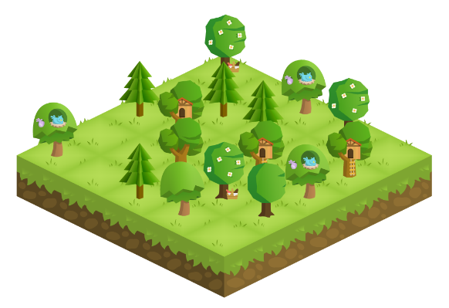
Things we might chat about but not pursue too much:
- Medicine: Learners with ADHD don’t have to take medication, although many do and find it is helpful for mitigating some of the symptoms of ADHD. However, that decision is really up to the learner and their prescribing doctor (And that conversation has probably already happened by now).

