

IT Tips for Apprentices
Spring 2026

Record meetings on Teams
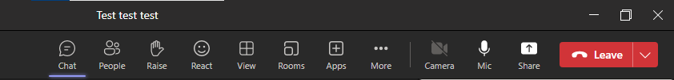
By recording meetings, attendees can replay your meeting at a later date. This gives everyone the chance to revisit what we covered. To start recording a meeting, click … More

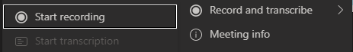
In the dropdown menu, click Record and transcribe and then Start recording.

Before using this, check your organisation’s rules and also make sure that everyone knows it’s being recorded and they are ok with that. If anyone isn’t OK with that, then do not record.

To stop the recording, repeat the steps above. Once recording is stopped, the video file will appear in the meeting chat.

Good to know
- This isn’t available in the free versions of Teams, so if you’re using it from a personal account, you’ll probably not be able to record.
- Your organisation might limit how long recordings are available for (e.g. 60 days).
- MS Teams also has live captions (AKA subtitles). These can really help people with hearing impairment. Individuals can turn their own Live Captions by clicking:
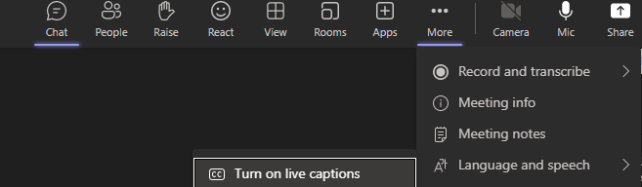
  - … More
  - Language and Speech
  - Turn on Live Captions

If joining the meeting on a mobile, click the … and click Turn on live captions.

You may also have the option for Teams to transcribe your meeting. This can be found in the Record and Transcribe option.

Otter AI to minute your meeting

Otter records your meeting. It has some extra benefits:
- It gives a summary of it.
- It lets you tag speakers and, once you’ve told it who is speaking, it can often recognise the same voice later.
- It adds key words to help you search through all you meetings (as well as search within each meeting).
- Apprentices can listen back to coaching sessions.

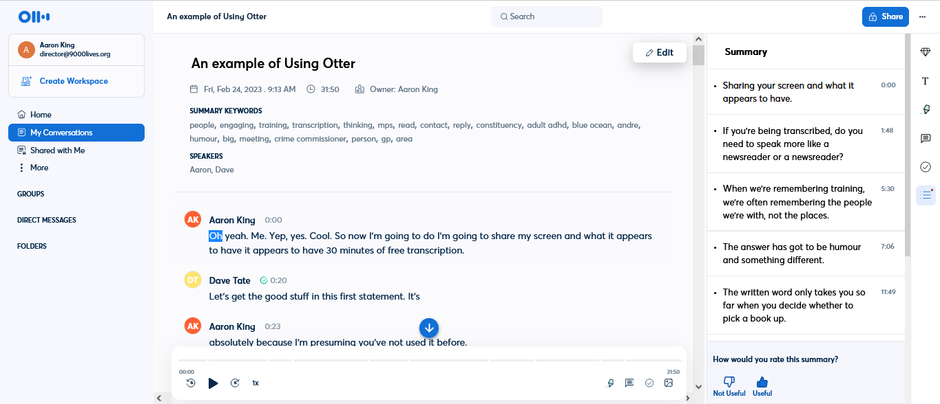
It is not perfect, especially if you use lots of technical jargon, but remember that a new human note taker would struggle with your jargon too.

Good to know before you start:
- “Um” is filtered out.
- You can teach it technical vocab, but it’s pretty limited on the free version (only 5 terms)
- Background noise makes it less accurate so if your apprentice is in a busy tele-communications environment, it’s just not going to work as a transcriber.
- Avoid speakers talking over one another. Otter can’t distinguish when multiple people are speaking over each other, which results in inaccuracies.
- If meeting online, use an external microphone or headset, rather than your computer’s built-in microphone.
- If meeting face to face, use an external microphone rather than your computer’s built-in microphone.
- Speak clearly and naturally, at your normal conversational tone and pace.
- You can train Otter to recognize your voice and automatic tag you in the transcript.
- The free version is 30 minutes max per transcription so you need to stop the recording after 30 minutes and then just click start again. It’s the AI equivalent of taking a cassette out of the cassette recorder, turning it over and recording on the other side!

Read Aloud (Microsoft)
Do you tire when reading longer texts. Would hearing it help? If so, there’s a free tool in Microsoft Word. It’s called Read Aloud.

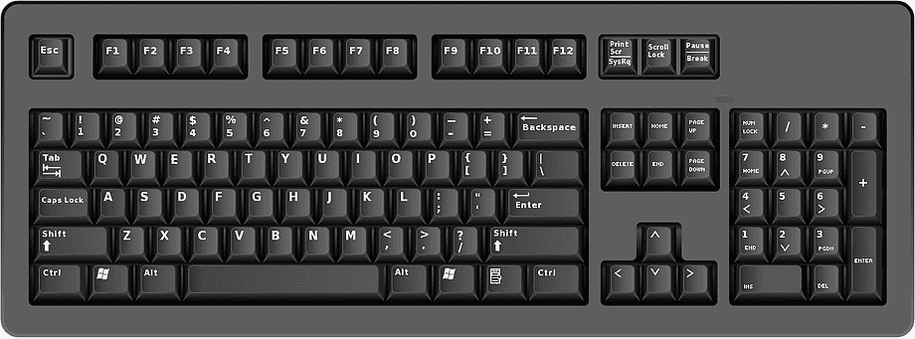
In your Word document, click the cursor at the start of the text that you want to have read aloud. Press Ctrl, Alt and Space. It now reads the text to you.

Pause & Restart Read Aloud
If you need to pause Read Aloud, press Ctrl and Space


There should also be a small control panel that has opened up in the top right of your screen. You can click the pause button on here.

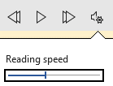
Slow or speed up the Reading Speed
If the speed is too fast for you to process, click the image of the speaker and gear. A slide bar appears and you use it to alter reading speed.

Quick Tip: There’s also a Read Aloud option in PowerPoint called Speak Aloud.

Read Aloud (Pdfs)
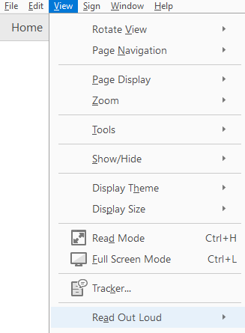
Read aloud in pdf is just as easy, although you might need to tell it when to move section (by clicking the next text).

Click View and then click Read Out Loud.

Click Activate Read Out Loud. It now reads out one section.

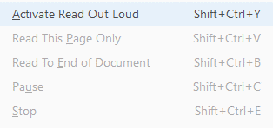
One section at a time can feel clunky, so go back into View / Read Out Loud and click Read this page only or Read to End of Document

If you use this tool often, learn the short cut keys:
- Activate read aloud Shift + Ctrl + Y
- Deactivate read aloud Shift + Ctrl + Y
- Read this page only Shift + Ctrl + V
- Read to the end of the document Shift + Ctrl + B
- Pause Shift + Ctrl + C
- Stop Shift + Ctrl + E

Speech to Text
You can dictate into MS Word. This is really helpful for when writing documents and emails – especially for people who find spelling or typing tiring. Press Windows + H


This brings up a bar with a microphone on. It might tell you it is listening straight away, or you might need to click the microphone.

Inserting punctuation and new lines
So how do you put in full stops, commas or new lines? You tell it.
- For full stops you can say “Full stop” or “Period” (a US term for full stop).
- For new lines, say “New line.”
- For commas, say “comma.”

You say this:
“The fox jumps over the lazy dog period new line The happy cat comma who is ginger comma plays with the tiny mouse period”

You get this:
The fox jumps over the lazy dog.
The happy cat, who is ginger, plays with the tiny mouse.

If someone comes in to talk to you, you can say “Stop listening” or click the microphone to pause the speech to text.

Good to know before you start:
- Help improve accuracy by speaking more like a newsreader.
- You can teach your computer to better recognise your speech in speech settings
- Don’t worry if it appears to be lagging behind. It’s sometimes listens for the end of the sentence to help it work out a particular word at the start of the sentence (just like humans sometimes do).
- If you have a repeated problem of it saying ‘initializing’ and not listening, it’s probably to do with your computer. If you have an IT department, ask them. Otherwise, it might be that you use Otter AI to transcribe your speech (even though that’s not quite what Otter is intended for).
- Before getting started you may need to download a speech pack (open speech to text via Windows +H and your computer will tell you if you need a download). This is quick and easy. It’s because your computer came with US speech to text and you need to download the UK version. This helps avoid your work being filled with in US English.

Dyslexia: Changing Background colours
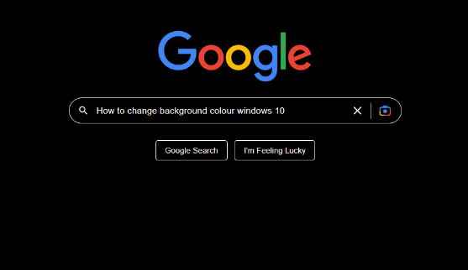
Some people with dyslexia report that they prefer different background colours to white. Background colours are typically pale blues, beige, lilacs. However, sometimes a dark background with light text might be chosen.

One rule doesn’t fit all computers and individuals, so it is best to Google it for your own operating system.

Visual Impairment: Screen Readers
A screen reader is not the same as like Read Aloud in MS Office or Read Out Loud in pdf reader.

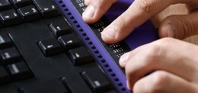
Screen readers are a computer programme for people with severe visual impairment that converts everything to speech (including tables, charts and pictures). It can be used alongside special braille keyboards.

It works with documents and webpages.
Some screen reading programmes are free. More advanced screen readers are available for purchase.
Become a really proficient user of a screen reader takes lots of time and practice so they are only recommended for people who will benefit from this large investment in time.


A rule of thumb is that, if the person doesn’t have a short or long cane, they won’t need a screen reader.
NVDA is short for Non-Visual Desktop Access. NVDA’s software is free and is a free way of converting every screen into speech.
A second free alternative is Jaws Screen Reader.
For sighted users, it is impractical but for those who are severely visually impaired, it can be essential for life.
Remember Read Aloud (which just reads the text) and Screen Readers (which read aloud text and images) are two different things.

Shortcut keys

Ctrl to Control the Programme
- Ctrl + P Print preview (and then press enter to print)
- Ctrl + O Open

Ctrl to Cut, Copy and Paste
- Ctrl + X Cut
- Ctrl + C Copy
- Ctrl + V Paste

Ctrl to Undo and Redo
- Ctrl + Z Undo
- Ctrl + Y Redo

Ctrl to Edit the Text
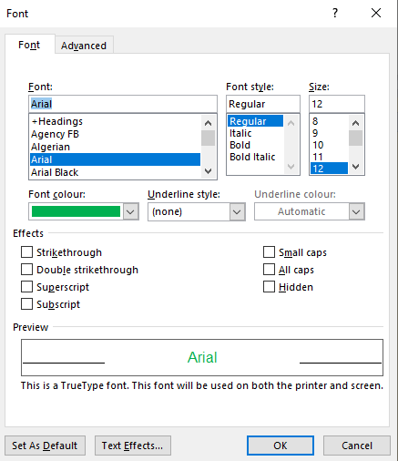
- Ctrl + B Bold
- Ctrl + I Italic
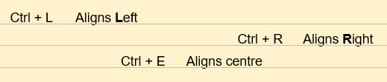
- Ctrl + D Opens your font options
- Ctrl + L Aligns text to the Left
- Ctrl + R Aligns text to the Right
- Ctrl + E Aligns text to the centre
- Ctrl + A Highlights all text - really useful to change all your font at once.

Ctrl to find things quick
- Ctrl + F: Great for finding a word or phrase on a Word doc or webpage.

Ctrl to move about faster
These hacks are really useful for hopping around your text to edit – without stopping to move the mouse.
- Ctrl + Right Arrow: Move the cursor to the right by one whole word.
- Ctrl + Left Arrow: As above but left.
- Ctrl + Up Arrow: Move the cursor up one whole paragraph.
- Ctrl + Down Arrow: As above but down.
And there’s also…
- Ctrl + Home Moves the Cursor to the start of your text.
- Ctrl + End Moves the Cursor to the start of your text.
- Ctrl + Delete: Delete a whole word (instead of just one letter).
- Ctrl + Backspace: Ditto.
- Ctrl + Enter Start a new page.

Lock your PC Fast
You’re dashing to a meeting and running late. Policy says you must lock your screen. Press Windows & L. This locks your computer by returning you to the log in screen.
To unlock later, enter your password as you normally do.

You left Caps Lock on?
Ever started typing when caps lock was on?
YOUR WRITING LOOKS LIKE THIS. THE GOOD NEWS IS THAT YOU DON’T NEED TO TYPE IT ALL AGAIN.
Do you normally delete it and retype it all? Stop. Just highlight your caps:

NOW PRESS Shift + F3. THIS SWITCHES your text into all lower case:

Now press Shift + F3 again. This switches your text into lower case with capital letters at the start of each sentence.

Five Keyboard Shortcuts for Web Browsing
- On the internet? Press space to scroll down a page.
- Gone too far? Press shift + space to scroll back up one page.
- Ctrl + T Opens new Tab
- Ctrl + W Closes that Tab
And… 5. Ctrl + F Find: Opens up a search box so that you can search the current web page for words or phrases: Very handy if you’re reading a long online pdfs.

The F keys
These two tips work for Word, Excel and PowerPoint
- F7 Spell check
- F12 Save As

