

Oak Meadow

Accessibility Plan

Sept 2026 – Sept 2029

This is our Three-Year Inclusion Plan

“No child left behind…
No barrier can’t be overcome…”

To chat to us about this plan, please get in touch

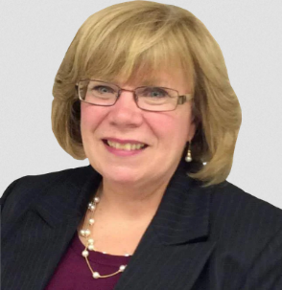

Janet Tolson, SENCo
0114 280 55 55
senco@oakmeadow.sheffield.sch.uk

Contents

1 | Welcome
2 | Our goals
3 | Explaining our plan
4 | How do we monitor our plan?
5 | Our Plan  - Our children’s learning  - Our classrooms and buildings  - Our written information

“This is our three-year plan for inclusion”

Welcome
When some people see the words Accessibility Plan, they think “Old news”. After all, schools have had accessibility plans since 2002. How could there be anything left to do?

If a school has accessible toilets and wheelchair ramps, it’s accessible, isn’t it?

Changes to buildings are especially important for people with physical difficulties. However, for most children with ADHD, an accessible toilet will not make a difference. For these children, improving access may mean pastoral support, extra 1:1 reading, or movement breaks. All of this can be achieved without laying any concrete or installing new toilets.

We may plan physical adjustments, but accessibility is about much more than buildings.


Accessibility doesn’t mean removing every barrier. Some barriers can’t be removed so we try to find creative ways to manage them.

If we cannot remove the barrier, we want to work together to get over it, under it, or round it.

Please read on…

Our Goals
These goals reflect our ambition and the things that our families and children say are important.

We have set some really big goals. Some might be even bigger than we can achieve. But we will do our best to reach them because they matter to the lives of our pupils.

1  All children can tell you about several disabled role models. | 2  There is no bullying of children because of their SEND. | 3  Every child leaving our school treats disabled people with respect and dignity.
6  All children leave Y2 with a receptive and expressive language level of at least 6 years and 11 months. | 5  Every child leaves every year group having been invited to at least three class mate’s birthday parties. | 4  No child leaves FS without having been invited to a friend’s house for a play date.
7  By Y4, all children with SEND are offered an intervention to understand their difficulties and potential. We’ll work with parents to agree what that looks like. | 8  Our twice-yearly parent sessions transform the level of SEND know-how in our families. | 9  Attendance of pupils with SEND is better than the whole school average.

10. The Final Word
Let’s say that on Haggstones Road, a mum gives birth early. It’s a difficult birth. The baby, Alex, is born at 26 weeks and is very unwell in the first few days of life. The difficulties at birth damage Alex’s newborn brain.

We want our school to be better by the time Alex starts with us than it would have been if Alex had started today.

We want Alex to read well, achieve in all our subjects, have great friends, and have excellent physical and mental health.

Explaining our Plan

What’s in our plan?
Our plan has three parts:
- Children’s learning
- Our physical space (that means our rooms and buildings)
- The written information that we provide

What belongs in our plan?
We do lots to maintain previous improvements. For example, we repaint white edges on outdoor steps to keep them safe for people with low vision. We don’t add this to our plan because our plan is about how we’ll make things better (and not just maintain the improvements that we’ve already made).

However, we will include any renewal of our autism training, as our knowledge grows each time we do it. The key question is: Will it make it better at the end of this plan than it was at the start?

An Accessibility Plan vs Policy
This plan covers both our accessibility plan and policy. We think it’s better for you, the reader, if we put it all in one place.

We have this plan because we want to power up inclusion. However, if you want to know the legal reasons why we would do it anyway, you can read Schedule 10 of the Equality Act. That law says that we must:
- Make our plans in writing.
- Cover the three areas above.
- Improve written information within a reasonable time. We must take account of the views of pupils and their carers about written information.

Governors must:
- Keep our plan under review during the three-year period.
- Make sure that our plan is implemented by allocating enough money, staff time and training.

Ofsted may check how well we have planned, reviewed and implemented our plan.

How do we use feedback to reflect on our success and to plan our next steps?
We will get information to help us with this plan in our annual parent survey.
We know that not every parent will have read the full plan. So we ask broader questions that help our planning. For example: Imagine you have a magic wand. You can change anything about how we support SEND learners, what would you change?

Once a year, we will ask our learners the same ‘magic wand’ question.

At any time, you can tell us your views on our plan (whoever you are). Contact us using the details on the front page of this plan.

How do we monitor our plan?

What will our SENCo do?
Our SENCo will review this plan every September. This means:
- Re-reading the plan.
- Making updates if needed.
- Chasing up colleagues if targets need further work.
- Reminding colleagues what actions they have in the new school year.

The SENCo uses the review of this plan to write their annual SEND development plan. This plan and the SEND development plan don’t have to match perfectly but they will overlap.

The SENCo will make sure that the updated plan is published on our website. After 3 years, they will report to governors on how effective the plan has been.

What Governors will do
Our Governors agree that the head teacher can approve and oversee the plan and interim reviews.

Governors will monitor the plan by visiting school each year in the summer term. They will focus on:
- In Year 1: Our classrooms and buildings
- In Year 2: The curriculum
- In Year 3: Written information

‘‘
An inclusive school is a great benefit to everybody – not just children with SEND, but it’s a great benefit to all of us, to share in our humanity…

It just makes us into better people, doesn’t it?

”

Sarah, a parent, gives her views in the report “Accessibility Plans as Effective Tools for Inclusion in Schools?”

Our Pupils’ Learning
This is the biggest section. Also known as ‘access to the curriculum,’ it is how we make every lesson and intervention even more inclusive.

When & Who? | Action | Comments | Impact | RAG
Jul 2028  Head | We will make SLCN a key priority in our 2028/29 School Improvement Plan so that this group narrows the gap with peers. | Barriers faced by SLCN pupils are hindering their progress, especially in KS2. Our School Improvement Plan will help us to tackle this.
Jul 2028  SENCo | We will provide new and refresher staff training in autism. | It will be three years since we last did autism training. So, we’ll ask experts from the council’s Autism Service to train our staff. This will help autistic learners get the best possible education.
Sep 2028  SENCo | We will provide expert help for children with mental health difficulties. | Once a week, a CAMHS specialist will come into school to work 1:1 with older learners.  They will also give advice to our staff. This will help staff to continue their great work on the four days that they aren’t in school.

Our Classrooms and Buildings
This is about how we’ll make changes to the physical environment to make school more inclusive.

When & Who? | Action | Comments | Impact | RAG
June 2028  SENCo | We will revisit our approach to display so that it inspires without being overstimulating. | Our SENCo will discuss this at leadership meetings so that we have a clear idea of what inclusive display looks like.  Our SENCo will then discuss this with all our staff in staff meetings. Then, classrooms will have more inclusive displays in September.
June 2028  Office manager | We will get a quote for acoustic panels in our dining hall. | Acoustic panels make it easier for learners to communicate with each other during lunchtimes.  However, we don’t know if we can afford these. So, we first need to find out how much they cost. We’ll then look at our budget for building work and see if it’s possible.

Our Written Information
This is about the information we write for children, but we also choose to include adult readers in this section. No one should be left behind.

When & Who? | Action | Comments | Impact | RAG
Jul 2028  SENCo | We will rewrite fire evacuation signs in Chalke Building rooms so that they are communication-friendly. | We will rewrite the signs with symbols above the text. We’ll use Widgit software. We will call MB (County Fire and Rescue) to show him the final draft. When we last spoke about it (Mar 2026) he indicated there would be no problem if that’s what the learners need.
Oct 2026  Office Manager | We will give our admin staff a training session on accessible writing. | Training will include:  - The Flesch Reading-Ease system  - Signalling headings  - Sans & Serif fonts  - Using 1.2 line spacing  - Sentence length  - Other ways to make information dyslexia-friendly  - Speech-to-text and text-to-speech  - How screen readers work  This will make it easier for everyone to read our letters and policies.
Oct 2026  Office Manager | We will put up signs (in both reception areas) to tell parents who feel overwhelmed by forms that we can help. | Signs will say:  “School Forms giving you a headache? Don’t get stuck. Please come to reception. We’ll do our best to lend a hand.  Mrs Elliott, Miss Green, Mrs Whitby. (NB include profile photos on sign).  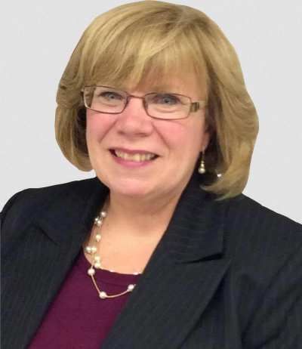  Health Forms giving you a headache? Don’t get stuck. Contact our SENCo, Mrs Tolson. You can ask at reception or email: senco@oakmeadow.sheffield.sch.uk

